Statement of Accounts
2023 - 2024

Contents
A. NARRATIVE STATEMENT i
B. ANNUAL GOVERNANCE STATEMENT 2023/24 xxxi
C. INDEPENDENT AUDITORS REPORT TO THE MEMBERS OF RUSHCLIFFE BOROUGH COUNCIL xlix
D. STATEMENT OF RESPONSIBILITIES FOR THE STATEMENT OF ACCOUNTS 1
E. THE FINANCIAL STATEMENTS 2
COMPREHENSIVE INCOME AND EXPENDITURE STATEMENT 2
MOVEMENT IN RESERVES STATEMENT (MIRS) 3
BALANCE SHEET 6
CASH FLOW STATEMENT 7
EXPENDITURE AND FUNDING ANALYSIS AND NOTES FOR THE YEAR 1 APRIL 2023 TO 31 MARCH 2024 8
F. NOTES TO THE ACCOUNTS 9
1. NOTES TO THE EXPENDITURE AND FUNDING ANALYSIS 9
2. INCOME AND EXPENDITURE ANALYSED BY NATURE 10
3. ADJUSTMENTS BETWEEN ACCOUNTING BASIS AND FUNDING BASIS UNDER REGULATIONS 11
4. TRANSFERS TO/(FROM) EARMARKED RESERVES 13
5. OTHER OPERATING EXPENDITURE 15
6. FINANCING AND INVESTMENT INCOME AND EXPENDITURE 15
7. TAXATION AND NON-SPECIFIC GRANT INCOME AND EXPENDITURE 16
8. PROPERTY, PLANT AND EQUIPMENT 17
9. INVESTMENT PROPERTIES 20
10. INTANGIBLE ASSETS 22
11. ASSETS HELD FOR SALE 22
12. FINANCIAL INSTRUMENTS 23
13. DEBTORS 24
14. DEBTORS FOR LOCAL TAXATION 24
15. CASH AND CASH EQUIVALENTS 25
16. CREDITORS 25
17. PROVISIONS 25
18. USABLE RESERVES 25
19. UNUSABLE RESERVES 26
20. CASHFLOW STATEMENT – OPERATING ACTIVITIES 31
20. CASHFLOW STATEMENT – OPERATING ACTIVITIES CONTINUED 32
21. CASHFLOW STATEMENT – INVESTING ACTIVITIES 32
22. CASHFLOW STATEMENT – FINANCING ACTIVITIES 32
23. MEMBERS’ ALLOWANCES 32
24. OFFICERS’ REMUNERATION 33
25. EXIT PACKAGES AND TERMINATION BENEFITS 33
26. EXTERNAL AUDIT COSTS 34
27. GRANT INCOME 34
28. RELATED PARTIES 36
29. CAPITAL EXPENDITURE AND CAPITAL FINANCING 37
30. LEASES 38
31. IMPAIRMENT LOSSES 39
32. DEFINED BENEFIT PENSION SCHEMES 39
33. CONTINGENT LIABILITIES 45
34. CONTINGENT ASSETS 45
35. NATURE AND EXTENT OF RISKS ARISING FROM FINANCIAL INSTRUMENTS 45
36. ACCOUNTING POLICIES 49
37. ACCOUNTING STANDARDS ISSUED BUT HAVE NOT YET BEEN ADOPTED 65
38. CRITICAL JUDGEMENTS IN APPLYING ACCOUNTING POLICIES 65
39. ASSUMPTIONS MADE ABOUT THE FUTURE AND OTHER MAJOR SOURCES OF ESTIMATION UNCERTAINTY 66
40. MATERIAL ITEMS OF INCOME AND EXPENSE 67
41. EVENTS AFTER THE BALANCE SHEET DATE 67
G. THE COLLECTION FUND 68
1. GENERAL 68
2. CALCULATION OF COUNCIL TAX BASE 68
3. COLLECTION FUND COUNCIL TAX BALANCE/REDISTRIBUTING SURPLUSES OR DEFICITS 69
4. NON-DOMESTIC RATES 69
5. NON-DOMESTIC RATES SURPLUS OR DEFICIT 70
H. GLOSSARY OF TERMS 71

A. NARRATIVE STATEMENT
Welcome to the Statement of Accounts
Introduction
As the Council’s Chief Finance Officer, I have pleasure in presenting the Narrative Statement to Rushcliffe’s 2023/24 Statement of Accounts. The Statement of Accounts is required by law and provides statutory and other information in line with professional best practice. In doing so, the Financial Statements continue to accord with International Financial Reporting Standards (IFRS) ensuring consistency with accounts produced by organisations in other sectors of the economy.
The Narrative Statement reports on the accounts by summarising key events and their financial impact as well as non-financial performance indicators against key corporate priorities and commentary on key risks. It also provides additional context on some of the issues and challenges that have faced the Council during the year. I hope that this Narrative Statement, and the information that follows, gives a clear picture of how Council Tax and our other sources of income are used to deliver a wide range of services. The Narrative Statement, along with the Annual Governance Statement and the Auditor’s report, are outside the scope of the Statement of Accounts, but all of the documents, as one, constitute the Council’s Financial Report for 2023/24.
The financial environment remains challenging with new and emerging pressures that continue to affect the Council’s income streams. The Council’s officers have continued to provide additional financial support to residents and businesses in the form of grants and reliefs. The cost-of-living crisis continues to impact on the Council’s income and expenditure, inflationary increases have been built into future year budgets, however future rates are still uncertain, and this may pose an ongoing pressure. Despite the volatile economic environment, the Council has continued to deliver the Medium-Term Financial Strategy focussing on maintaining quality services for its residents. The Council strives to grow the Borough and over the last year has made significant progress on large development projects. The Council Corporate Priorities below remain a focus for the Council:
- Supporting economic growth to ensure a sustainable, prosperous and thriving local economy.
- Maintaining and enhancing our residents’ quality of life.
- Transforming the Council to enable the delivery of efficient high-quality services.
- Playing our part in protecting the environment today and enhancing it for future generations.
Should you have any queries regarding these accounts or suggestions as to how we could improve the information provided please forward them to me at finance@rushcliffe.gov.uk.
Peter Linfield
Deputy CEO and Director - Finance and Corporate Services

- The Statement of Accounts
The Director (Finance and Corporate Services) is the statutory officer responsible for the proper administration of the Council’s financial affairs (sometimes referred to as the Chief Finance Officer or S151 Officer). They are required by law to confirm that the Council’s system of internal controls can be relied upon to produce an accurate Statement of Accounts. To do so, the Chief Finance Officer ensures that the Council maintains proper and up to date accounting records and takes all reasonable steps to prevent and detect fraud and any other irregularities. The Council’s Statement of Assurance for 2023/24 (known as the Statement of Responsibilities for the Statement of Accounts) appears on Page 1 of the Statement of Accounts.

The Statement of Accounts has been produced in accordance with The Code of Practice on Local Authority Accounting (‘the Code’) developed by the Chartered Institute of Public Finance and Accountancy (CIPFA) and the Council’s Accounting Policies, which are written to take into account the Code, and are outlined on pages 50 to 68 of the Statement of Accounts.
The map below shows some key statistics for the borough of Rushcliffe
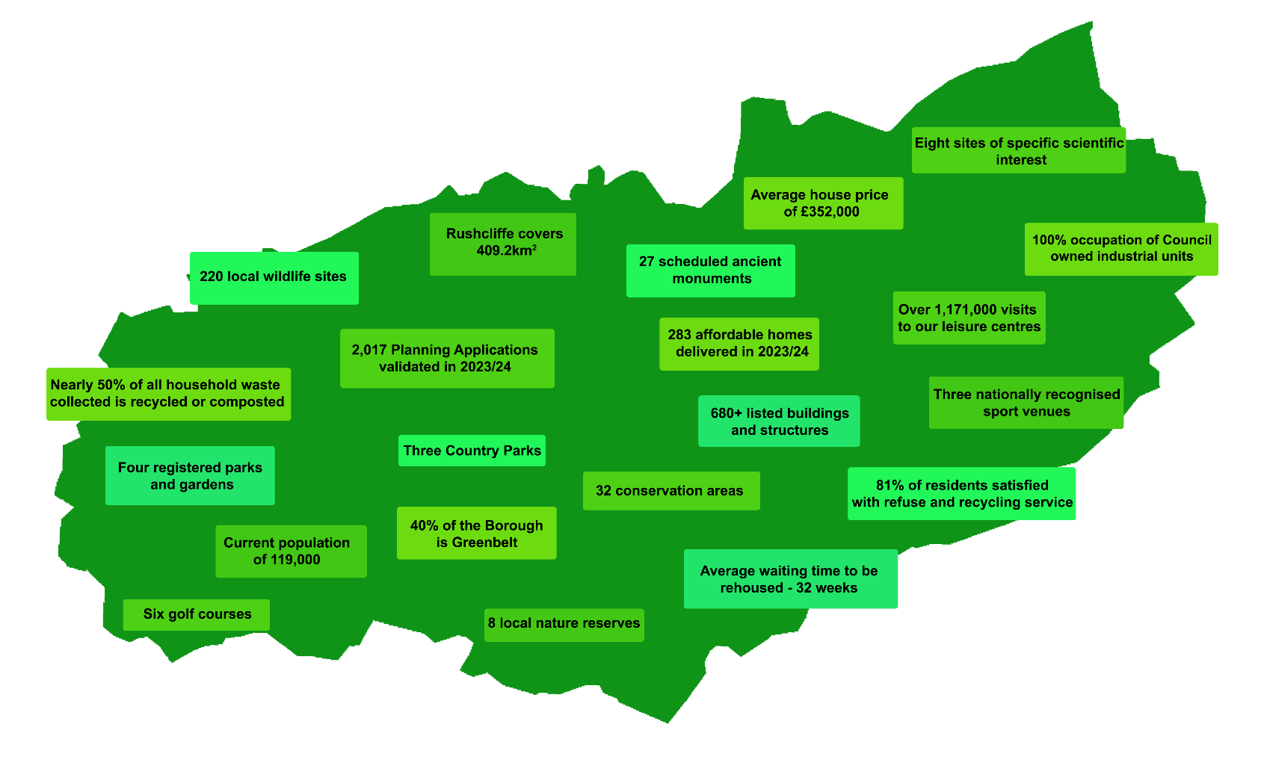

- Delivery of the Corporate Strategy
The delivery of the Corporate Strategy 2024-27 is reported quarterly to the Council’s Corporate Overview Group. A new Corporate Strategy was approved by Council 7th December 2023.

We had ambitions to deliver major projects that align outcomes with our four corporate themes:

Supporting economic growth to ensure a sustainable, prosperous and thriving local economy

Maintaining and enhancing our residents' quality of life

Transforming the Council to enable delivery of efficient high-quality services

Playing our part in protecting the environment today and enhancing it for future generations.

Here are some examples of what we achieved:

As well as achieving all of this, we also:

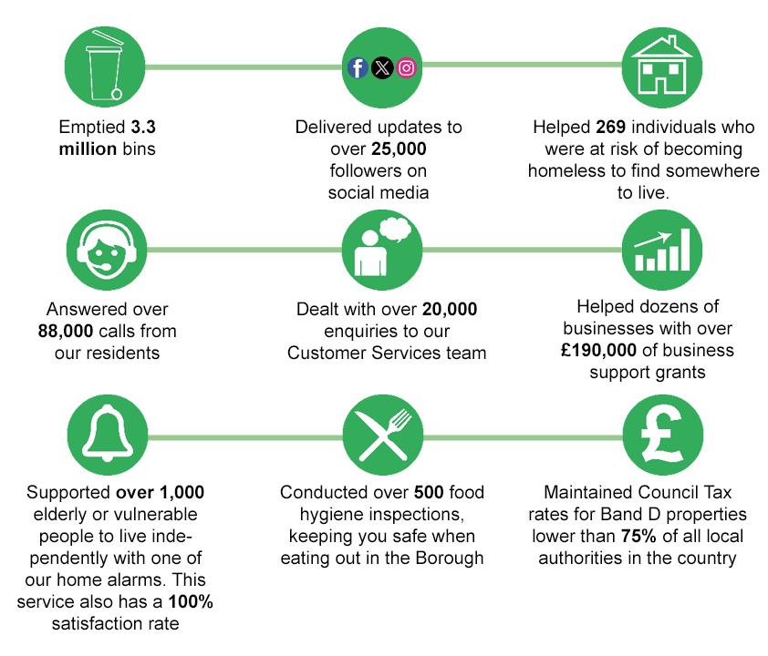

- Risk Management
The Council’s Risk Management Strategy was refreshed and updated in April 2023 to ensure that it reflects the current operational structure. Reports to Governance Scrutiny Group contain updates on the risk management arrangements, and the Group’s responsibility is “to oversee and scrutinise the effective management of risk by officers”. The strategy is reviewed every three years by the Risk Management Group (RMG) and Governance Scrutiny Group provides scrutiny of risk registers.
The Executive Management Team has met as the Council’s RMG in order to oversee the management of risk across the organisation and review, where necessary, strategic, operational and opportunity risk. The number of risks within the registers will fluctuate throughout the year as active risk management is undertaken.
Changing pressures facing local government and the proactive work of managers to identify risks as they emerge, will continue to influence new risks added to the register. This demonstrates the Council’s aim to be proactive to mitigate risk as soon as possible after identification. There are currently 30 corporate risks, 16 operational risks and 3 opportunity risks. Risks are reviewed each year as part of the Service Planning process and changes to risks are referred to RMG for approval.
Examples of risks that have been added or removed in 2023-24 are:
Risks removed:
- CRR_ FCS06 Lack of funding from partners
- CRR_ FCS26 Short term loss/failure of main ICT systems
- OR_DEG01 Failure to manage legionella issues
- OR_NS02 Disruption and lack of fuel preventing collection of domestic waste

Risks added or proposed by Risk Management Group:
- Failure by Returning Officer and elections staff to comply with the relevant legislation and/or deliver the practical aspects of the election, as a result of improper resourcing or inadequate training, leading to an adverse impact on reputation and results in legal challenges
- Council is forced to find alternative supplier or bring back in-house a service ceasing to be delivered by a public sector partner, leading to increased costs and operational pressure
- Dissatisfaction within the local community, as a result of ineffective administration of the UKSPF fund for the borough, leading to the potential loss of future funding and a failure to realise the benefits of UKSPF
- Failure to deliver the Compulsory Purchase Order at Flintham as a result of poor partnership working, leading to an inability to make the site safe and available for development

Following recommendations from Zurich, all risk descriptions have been rewritten to better describe what the risk is, what triggers the risk to occur and the impact of the risk occurring.

The Council’s Medium-Term Financial Strategy highlights key financial risks; the higher rated risks are as follows:

Risk | Likelihood | Impact | Action
The Council is unable to balance its budget and the budget is not sustainable in the longer term as a result of increased inflation (largely driven by pay and utility cost increases) and government funding reductions with uncertainty due to one-year settlement. | Medium | Medium | Going concern report presented to Governance Group to confirm that the Council has sufficient reserves to withstand the short-term financial shocks. Budget set to include latest assumptions on inflationary increases. Further plans for the transformation strategy to mitigate risk over the longer term. Budget reporting processes and use of budget efficiencies and reserves. Maintain reserves at a sufficient level.
Fluctuation in Business Rates linked to changes in the local economy and revaluation of major business rates payers. | High | Medium | Utilising NNDR1 (Government business rates return) for business rates forecast for next year which takes into account valuations.  Continued monitoring of the collection rates and appeals for business rates.  Use of reserves as necessary to mitigate ‘one-off shocks’.
Central Government policy changes e.g. Fairer Funding, ceasing NHB and Business Rates reset leading to reduced revenue; or increased demand on resources for example environmental policy changes with regards to waste will create future financial risk (Extended Producer Responsibility (EPR) and weekly food collections). | Medium | Medium | Engagement in consultation in policy creation and communicating to senior management and members the financial impact of changes via the MTFS. Budget at safety net position for business rates in years of uncertainty. Inclusion of demand and/or income in the MTFS and Capital Programme and calculations to understand the impact of any proposals.
Insufficient staff capacity – skills, knowledge, and availability etc impacting on the Council ability to operate efficiently and to deliver the transformation plan. | Medium | Medium | Ensuring market rates are being paid, internal staff development and promotion and development of staff benefits package. If necessary, use of agency support.
Environmental carbon reduction and bio-net diversity commitments leading to greater pressure on revenue and capital budgets. | High | Medium | Climate Change Reserve being replenished, ongoing review of significant projects and outcome of scrutiny review. A vehicle replacement reserve which will help fund, for example, electric vehicles. Apply for external funding where possible.
Increased demand for services such as homelessness and migration or general housing growth. | Medium | Medium | Additional government funding and internal resources provided.
Reducing demand as a result of a contracting economy, higher inflation and reduced personal disposable incomes. For example, less housing being built and bought, impacting on planning income. | Medium | High | Performance indicators and current financial due diligence via quarterly reporting to Cabinet and Corporate Overview Group (COG). Adjusting cost base as necessary.
Risk of increased capital programme costs due to either increased demand (e.g.DFGs, Traveller’s site) or inflation. | High | High | Continuation of the waiting list for Disabled Facilities Grants (DFGs). Working with Notts’ authorities on a more equitable distribution of resources. Further resource in capital reserves to be appropriated if efficiencies are identified.
Insufficient capital resources to fund the capital programme. | Medium | Medium | Ongoing cashflow management. The Council has the ultimate recourse to borrow. Review of Capital Programme to prioritise.
Opportunity for additional business rates from the Freeport/Development Corporation or risk of liabilities if either does not progress. | Medium | Medium | Continue to monitor progress and inform business rate assumptions through Officer working Groups/Board.
Risk of financial loss resulting from the decline in the capital value of pooled investments. | Medium | Medium | Treasury Capital Depreciation Reserve to mitigate any losses. Regular monitoring of environment and fund values. Seek advice from Treasury Advisors on strategy going forward.
The ongoing impact of flooding in the borough linked to climate change. | Medium | Medium | The Council continues to deliver flood relief schemes and bears the impact of the Internal Drainage Board levy. Contingency budget maybe utilised if the levy continues to rise. New Flood Resilience Reserve created.
Understanding the impact on RBC of the Combined Mayoral Authority. | Medium | Medium | Continue to play a role in the inaugural year of the authority, and going forward, and report implications back to Council through its usual governance processes.

- Revenue Expenditure and Income
The Council receives and spends money from various sources. The income comes primarily from local residents in the form of Council Tax, and local businesses as Business Rates. Each year the Council spends its money on key services, delivered in accordance with our local priorities and legal requirements.
When setting the budget for 2023/24 inflation and pay awards were the main areas of risk, the budget allowed for a 4% growth in staffing costs, the actual increase averaged 6% but was offset by vacancies during the year. Utilities budgets were set at a prudent level and, as fuel prices were lower than expected, has resulted in savings of £0.261m for 2023/24. Interest rates remained high during the year, and this has delivered £0.528m of additional interest. Main overspends related to a property related legal claim £0.445m reduced income from planning £0.351 due to drop in demand from new developments, Rushcliffe Oaks Crematorium £0.213m (overall net surplus £61k) due to trading estimates being overly ambitious in the first year (original assumptions distorted by the impact of Covid) and Streetwise £0.131m due to legacy contracts pre-transfer to the in-house model.
The following table demonstrates where money was spent in 2023/24, showing a net underspend on direct costs of £0.315m against budget. This underspend is increased by additional grant income and business rates pool to give an overall underspend of £1.663m.
 | Original Budget £'000 | Revised Budget £'000 | Revised Outturn £'000 | Revised Variance £'000
Chief Executive | 2,314 | 2,319 | 2,807 | 488
Finance & Corporate | 4,100 | 4,078 | 3,431 | (647)
Development and Economic Growth | (155) | 55 | 432 | 377
Neighbourhoods | 7,649 | 8,243 | 7,766 | (477)
Sub Total | 13,908 | 14,695 | 14,436 | (259)
Capital Accounting Reversals | (1,895) | (1,895) | (1,895) | 0
Minimum Revenue Provision | 1,311 | 1,311 | 1,255 | (56)
Total Net Service Expenditure | 13,324 | 14,111 | 13,796 | (315)
Grant Income (including New Homes Bonus) | (2,054) | (2,054) | (2,273) | (219)
Business Rates (including SBRR) | (4,905) | (4,905) | (6,065) | (1,160)
Council Tax | (7,953) | (7,953) | (7,953) | 0
Collection Fund Deficit | 506 | 506 | 537 | 31
Total Funding | (14,406) | (14,406) | (15,754) | (1,348)
Net Transfer to/(from) Reserves | 1,082 | 295 | 1,958 | 1,663

The main sources of revenue funding are detailed below. The table demonstrates the Council’s reliance on local taxation to fund net council expenditure. Of the grants funding, £1.414m is New Homes Bonus, largely used to finance capital expenditure. New Homes Bonus was planned to cease after 2022/23, however, there has yet to be any announcement on the 2021 consultation and consequently NHB has continued to be extended by r a further year, and again extended with £1.5m due for 2024/25.

Source: Financial Outturn Report 2023/24
The deficit position on the Collection Fund (page 67) at 31 March 2023 of £1.917m has been recovered from Rushcliffe Borough Council and the major preceptors, the balance as at 31 March 2024 is a surplus of £0.454m this will be redistributed during 2024/25.
The Movement in Reserves Statement (page 3) demonstrates prudent financial management throughout the year, with the Council having had few reasons to call on its reserves. The original planned net transfer reserves of £1.082m was and adjusted to £0.295m to reflect carry forward commitments. At the end of the year there is a net transfer to reserves of £1.958m, a net increase of £1.663m. Overall Earmarked reserves have increased by £1.274m (£1.958m revenue and £0.684m capital).
The £1.274m net transfer to reserves is made up of £5.069m transferred to reserves net of £3.795 transferred from reserves. Of the £5.069m transferred to reserves, £1.414m was New Homes Bonus (NHB) and £1.663m to the Organisation Stabilisation (OS) Reserve to meet carry forwards and reserve appropriations (including £0.425m to the climate change reserve, £0.331m for replacement finance and income systems, £0.235m for rising Housing Benefit costs and £0.1m for Development Corporation). Much of the £3.795m use of Reserves was the use of New Homes Bonus to offset Minimum Revenue Provision (MRP) charges in relation to the capital cost of Rushcliffe Arena and Bingham Arena and Enterprise Centre (£1.311m); and planned transfers to meet revenue commitments. The General Fund Reserve Balance therefore remains unchanged from 2022/23 at £2.604m. Reserves are available to meet future cost pressures thus:
- Enabling delivery of the transformation programme by which the Council will balance future budgets and continue to deliver high quality services;
- Smoothing saving requirements between financial years;
- Enabling the Council to deal with the volatility from changes to central government funding methodology (such as Fairer Funding Review and retained business rates which have been further delayed);
- Enabling the Council to minimise the impact of Government Policy such as the Extended Producer Responsibility for Packaging and the Environment Act;
- Funding capital expenditure including enhancement of property, plant and equipment and vehicle replacement;
- Ensuring the Council’s IT infrastructure and equipment is of sufficient quality to facilitate the delivery of modern services;
- Ensuring the Council is equipped to deal with unforeseen reductions in income or increased spending pressures such as the current cost of living; and
- Allowing the Council to facilitate growth and pursue opportunities such as the Development Corporation and Freeport.

- Capital Expenditure and Income
The following chart shows the breakdown of Capital Expenditure in 2023/24:

Source: Capital Expenditure and Financing (note 29)

The chart above shows the main area of capital expenditure relates to acquisition of vehicles, plant and equipment £2.762m, 41%, with the release of Capital Grants and Contributions as the next highest £2.174m, 32%. These are discussed further below.
As well as delivering day to day services, the Council also spends money on capital works, creating or enhancing assets which are shown on the balance sheet primarily as Property, Plant and Equipment, or as Investment Property. Key areas of capital expenditure in 2023/24 comprise:
Vehicle, Plant and Equipment - £2.762m. The majority of which relates to the vehicle replacement programme £2.328m. This includes the replacement of 9 refuse vehicles £1.839m and the purchase of Streetwise vehicles from lease contracts £0.328m.
Other Grants and Contributions - £2.174m. Monies released to finance capital assets owned by third parties. Primarily this expenditure was on Disabled Facilities and Better Care Funding Grants £0.996m, Home Upgrade Grants (HUG1) and Local Area Delivery Grants (LAD3) Green Energy Grants £0.435m and support for registered housing providers for affordable housing £0.416m
Assets Under Construction - £1.271m. Of which, £1.265m has been spent on Cotgrave and Keyworth Leisure Centres as part the enhancement works which include energy efficient measures as part of the Councils commitment to carbon reduction.
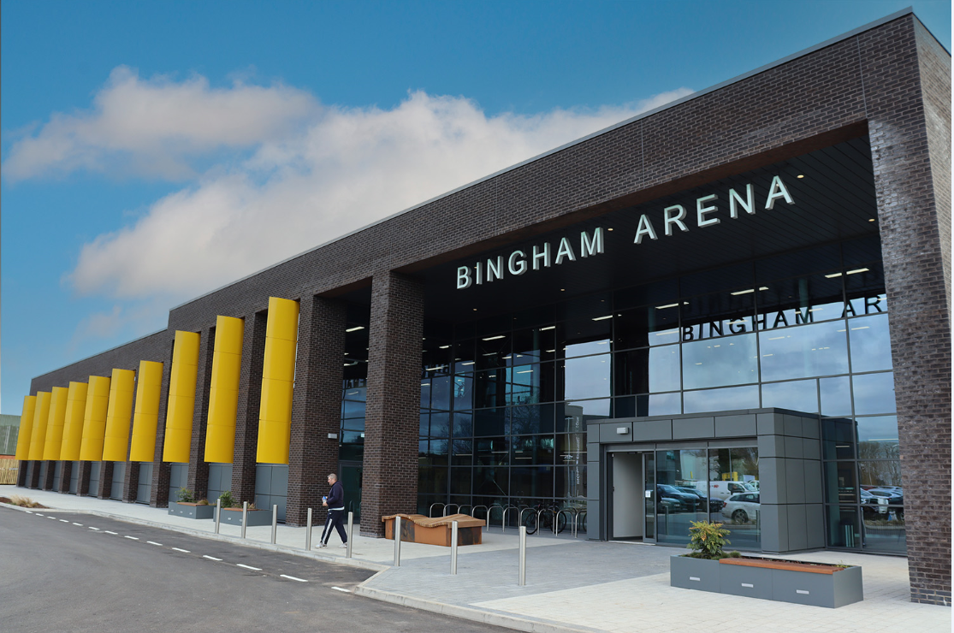

Bingham Arena
The Council has to ensure its Capital Programme is not only prudent, but also affordable and sustainable. In 2023/24 the Council spent £6.8m compared to an overall Capital Programme of £12.5m giving rise to a variance of £5.7m. This is mainly due to programme rephasing and the carry forward commitments which total a net of £4.2m. The most significant of which are £0.763m for support for registered housing providers for affordable housing, £0.480m retrofit grants for energy saving measures and carbon reduction, £0.4m for Rushcliffe Oaks post enhancement works and potential VAT payment and £0.356m HUG green energy grant funding. In addition, savings of £1.558m have been realised mainly due to the completion of two large projects; Bingham Arena and Enterprise Centre £0.678m and Rushcliffe Oaks Crematorium £0.797m.
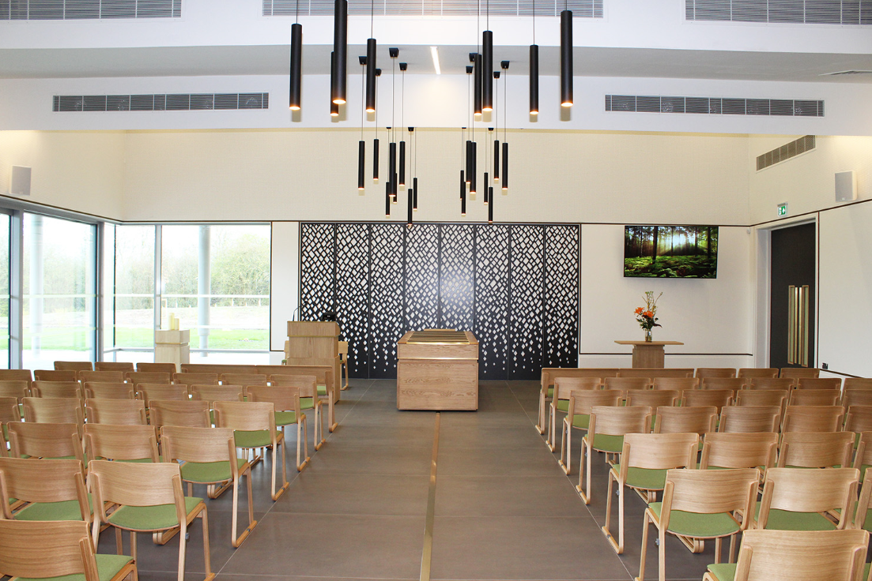
Inside the Chapel at Rushcliffe Oaks Crematorium
The chart below shows the breakdown how Capital Expenditure in year was funded.

Source: Capital Expenditure and Capital Financing - Note 29 (excluding items used to bring down internal borrowing; application of capital receipts £1.5m, Section 106 £0.6m and MRP £1.3m)
Capital resources available in 2023/24 allowed for all capital expenditure to be met without recourse to external borrowing. The key elements of funding comprise:
Capital Receipts - £3.026m 45% of capital expenditure was covered by capital receipts. The final sum from the overage agreement in place at Sharphill Wood was received in 2023/24. These sums, together with historical capital receipts, were used to fund: £2.028m vehicle replacements, £0.208m Cotgrave and Keyworth Leisure Centre enhancements and £0.133m Disabled Facilities Grants.
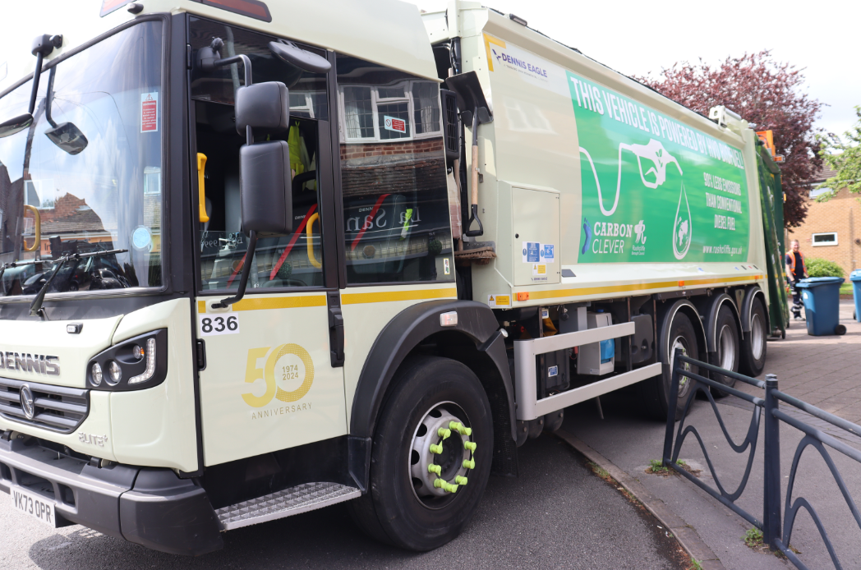
One of Rushcliffe’s Waste Collection Fleet
Government Grants - £2.540m 38%, of this, £0.950m Salix Funding for Cotgrave Leisure Centre, £0.762m awarded to the Council under the ‘Better Care Funding’ arrangements used specifically to fund Disabled Facilities Grants; and £0.435m came from the Department for Energy Security and Net Zero in relation to HUG (Home Upgrade Grants) and LAD (Local Area Delivery Grants) Green Energy Grants.
Use of Reserves - £0.684m 10% of expenditure: £0.3m for vehicle replacement, £0.15m for play area replacement and £0.1m for Cotgrave Leisure Centre Enhancements.
In 2016/17 and 2017/18, the Council used internal resources (internal borrowing) to temporarily finance the completion of the Arena development and Cotgrave employment units. There was a need to use a further £2.5m to meet part of the capital expenditure on Bingham Leisure Hub in 2021/22 and a further £7m in 2022/23 for Bingham Leisure Hub and the Crematorium. Where this happens, Central Government legislation requires the Council to make a charge to its revenue budget over time, to reinstate the Council’s resources. The Council has chosen to make a payment of around £1.3m a year, until the balance of internal borrowing is recovered. (See the Capital Financing Requirement note 29). The charge (MRP) to the revenue budget has been covered by the release of New Homes Bonus reserves to wholly mitigate any impact for Taxpayers and exceeds the amount we would have to pay if it was based upon the asset lives. In 2023/24, the Council was able to apply £1.5m capital receipts and £0.6m Developer Contributions to reduce the Capital Financing Requirement. This will mitigate MRP charges in future years.
At 31 March 2024, the balance in the Usable Capital Receipts Reserve stood at £3.422m (2022/23 £1.085m). The Council continues to generate resources through the planned disposal of assets deemed surplus, preserved rights to proceeds from sales of ex-Council House Stock. During 2023/24 £7.590m of capital receipts were received, of which £7.4m is due to the disposal of Hollygate Lane with £3.7m deferred to 2024/25.
Looking ahead, the Council has approved a Capital Programme for 2024/25 which includes the continuation of the major enhancement works to Cotgrave and Keyworth Leisure Centres, ongoing support for registered housing providers and Disabled Facilities Grants and enhancements to community buildings. The Council intends to support this expenditure through the continued application of Capital Receipts, use of Reserves, Government and Other Grants and Contributions. As the available capital resources are depleted, there may be a need to undertake some further ‘internal borrowing’ which will potentially require an increase in the Minimum Revenue Provision (MRP). Up to 31 March 2024, the MRP charge to the revenue account was offset by a release of New Homes Bonus (NHB) to wholly mitigate the impact of the internal borrowing on the Taxpayer. The ability to continue to do this will continue to be reassessed as part of the MTFS. The future levels of ‘internal borrowing’ and the potential need to undertake external borrowing will be dependent upon future capital income streams and receipt of monies that can be set aside into reserves, particularly NHB versus future capital demand.
- Major Service Developments and Future Challenges
Despite the ongoing impact of the cost-of-living and inflationary pressures, further compounded by national living wage increases and pay negotiations, the Council has again met the many challenges the financial year posed.
The Council continues to invest significantly in its services and assets and is dedicating more resources to green projects and mitigating the impact of localised flooding. It has over the past year continued to distribute funding to improve the energy efficiency of homes within the borough and has supported local residents and businesses by distributing dozens of UK Shared Prosperity Fund project grants.
The Council is currently debt-free and therefore not impacted by significant increases in interest rates on borrowing faced by some authorities and in a time of significant pressures and real terms decreases in funding, is continuing to embrace opportunities that support the economic growth and development in the Borough and maintain discretionary services valued by residents.
Budgets have focused on challenges but built on opportunities whilst responding effectively to the combination of the legacy of Covid and international conflict has had on inflation. The Council faces further challenges going forward and is not immune to the risks faced by many other councils across the country. The Council continues to identify efficiencies and has had to do so given inflation pressures outstripping growth in Council Tax income. The stable financial position compared to many councils is in conjunction with keeping Council Tax low and further assisting residents with cost-of-living increases.
The objective remains to continue to deliver excellent services to the community whilst supporting the most vulnerable such as the homeless and balancing support of tackling climate change, improving the environment and focusing on continuing to grow the Borough as a great place to both live and work.
Budget pinch points are not far away with a pincer movement on the Council’s finances as both revenue and capital resources face their own pressures. With revenue the ongoing impact of inflation has increased the challenge of finding both economies and efficiencies going forward. For capital resources are being exhausted and new avenues of funding, whether that is through external funding or disposing of assets, for example, are essential to ensure core services continue to be provided.
Quality of Life
The council has continued to enhance the quality of life for its residents including;
- Investment in play areas:
  - Adbolton Lane play area in Lady Bay, £80k, with 11 new items added, featuring work to increase accessibility options such as an inclusive wheelchair see-saw
  - West Bridgford’s popular Boundary Road play area, £63k of refurbishment, including the installation of a new multi-climbing unit and accessible see-saw.
Opening of the new Adbolton Playground in Ladybay

- Enhancement of leisure facilities:
Rushcliffe Country Park remains a leisure focal point of the borough and in July 2023 received national recognition, being named the best budget and family-friendly picnic spot in England.
There was continued investment in the park including:
  - building a new natural wood shelter adjacent to the Café to provide visitors additional seating for all weathers
  - £45k capital investment in path repairs
  - New and refurbished toilets and shade sails to enhance the visitor experience
Following the opening of the £20m Bingham Arena and Enterprise Centre last year there is a further capital programme of £24m investment over the next five years, which includes improvements at Keyworth and Cotgrave leisure centres.
- Improvements to customer experience
A new public facing website was created and launched in May 2023, including extensive work to update content, streamline navigation and to improve user experience with specific focus on accessibility needs.
- Supporting local groups and Parish Councils
The Council secured UKSPF grants for community groups and Parish Councils aiding dozens of development projects over the last 12 months that included benefiting many residents with a review of housing benefits claims, energy rebates and pension credit take up. UKSPF funding has also been utilised to fund a life-saving defibrillator project for sports venues with fourteen sports venues in the borough benefitting from the Safe Hearts in Sport initiative, which has equipped the venues, sports clubs and their coaches / volunteers with the tools and resources to ensure anyone facing a cardiac emergency is prepared and knows what to do.
Local groups have been supported via the Reach Rushcliffe fund, providing more than £9k worth of financial support. They have included funding to help re-develop Ruddington Paradise Allotments, a community garden co-ordinated by Rushcliffe Social Prescribing team to support residents’ health and mental wellbeing. A charity raising football team, Sands United FC Nottingham, who support bereaved fathers have also benefitted from funding to aid their growth and development.
- Hosting a varied schedule of events
Thousands of residents once again attended Council events such as Lark in the Park, Taste of Rushcliffe and Sunday Cinema Experience, with the standout being Proms in the Park, which attracted over 8,000 visitors throughout the day, a record for the event.
All items on the 2023 events calendar received overwhelmingly positive feedback including the annual Christmas Lights Switch-On in West Bridgford. There was also a first national swim gala hosted at Bingham Arena, highlighting its status and quality as a venue to be considered just months after opening.
The high-profile Celebrating Rushcliffe Awards were again hosted by the Council, bringing together finalists chosen from a record number of nominations across ten categories, each sponsored by a local business with the winners announced at the event, shining a light on amazing people and businesses within the borough.
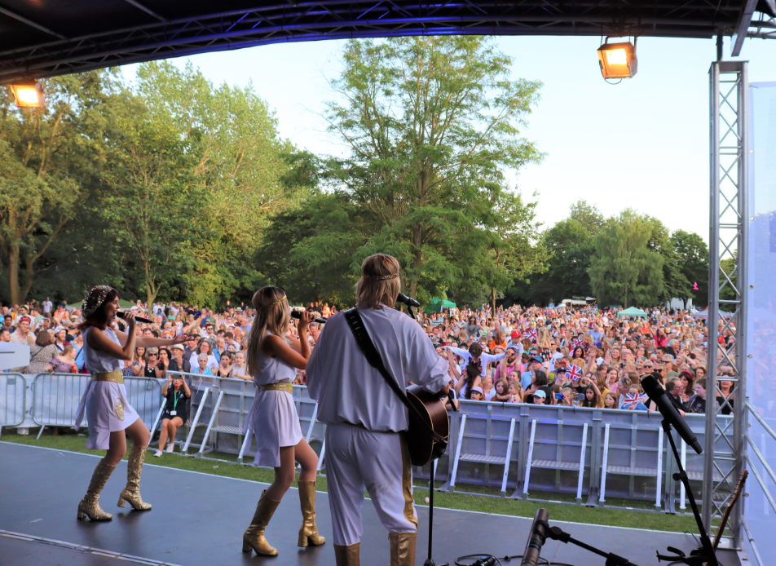
A tribute band entertain the biggest ever crowd at Proms in the Park
- Improving community safety
To help maintain and improve the safety of residents, the Safer Streets 4 project in the Trent Bridge area, implemented new CCTV and support for local businesses to trade more safely and was later complemented by the Safer Streets 5 project in Bingham approving further CCTV support.
The Council’s Home Alarms service which provides homeowners and private tenants with independence and reassurance at the touch of a button, secured its eighth consecutive customer satisfaction rating of 100%.
Efficient Services
The Council has ensured that its services deliver value for money whilst addressing the significant budget pressures the Council must address over the medium term. The Medium-Term Financial Strategy (MTFS) has been developed at a time of significant economic uncertainty with inflation remaining elevated impacting on residents, businesses, and the Council. Whilst the Council faces financial constraints, both the revenue and capital budgets delicately balance the need for efficiency and economy with the desire for growth and the aim of encouraging economic development in the Borough and supporting the vulnerable, to achieve the Council’s Corporate Priorities.
Detailed budget proposals for 2024/25 included a Transformation and Efficiency Plan (TEP) to deliver the anticipated efficiency and savings requirement and meet the requirements of the Government’s Productivity Plans. The MTFS reflects the significant increases in inflation offset partially by the positive effect on the Council’s investment returns due to higher interest rates but also the further delay in Business Rates reset.
Council Tax for 2024/25 increased by £3.93 to £157.88 (2.55%). This still means that Rushcliffe’s Council Tax remains the lowest in Nottinghamshire and amongst the lowest in the country. In line with changes in Levelling-Up legislation, the Council introduced a premium for properties classified as ‘second homes premium’ with 100% of the amount of Council Tax charged after one year of a property being empty, further assisting bringing properties back into use at a time of increased housing shortage.
Business Rates have been affected by the de-commissioning of Ratcliffe on Soar Power Station, reducing income to 50% in 2024/25 and zero from 2025/26 although much of the loss in income has been mitigated by the growth in business rates within the borough. Ongoing delays to proposals for a review of the Business Rates system, continues to make forecasting difficult but the Council anticipates that the reset will be delayed until 2026/27 at the earliest and has therefore set a budget of £5.463m in 2024/25 and projections for 2025/26 of £5.676m in retained Business Rates.
New Homes Bonus (NHB) was due to cease after 2023/24, however, in the settlement it was announced that the Council would receive a final payment in 2024/25. It is not yet known if there will be a replacement for this scheme and therefore the Council has assumed zero from 2025/26. The General Election and its results will impact future public financial policy and we await clarity on this going forward.
The budget allows for 5% growth in staffing costs for 2024/25 with salary costs rising due largely to the impact of the rising minimum national living wage impacting national wage settlements. Inflationary pressures continue with increases assumed for fuel (8%), contracts (3%- 6%) and utilities (3%) These pressures demonstrate the cost-of-living challenges facing residents, businesses and the Council.
Some fees and charges have been increased to offset increased costs caused by abnormal inflation and pay increases although limiting these in areas for the more vulnerable residents such as the Council’s Home Alarms service. Commercial investment income will reach £2m over the period of the MTFS accounting for 16% of fees and charges income. This is continually managed and proportionate given the risks and opportunities associated with such investments.
The net budget position over 5 years shows an overall deficit of £1.585m (4% of annual gross expenditure) and whilst this can comfortably be accommodated by use of reserves in the short term, taking into account resource predictions, spending plans and savings, further transformation and efficiency savings will need to be identified to bridge the gap although this gives the Council time to understand the financial landscape after the next general election. Given pressures already materialising in relation to Housing Benefit and the impact on employees, contracts and supplies and services, of inflation, the budgetary gap is expected to worsen.
The Council has a number of earmarked reserves held primarily to support delivery of Council priorities and mitigate specific risk and this year, in response to the recent flooding, includes a new Flood Grant and Resilience Reserve. The balance of reserves overall is largely stable over five years, reducing slightly from £8.7m to £7.4m mostly as a result of the use of the Organisation Stabilisation Reserve to balance the deficit over the period of the MTFS. The financial environment remains volatile therefore it is essential that the Council maintain sufficient reserves to ensure the Council can withstand any unexpected shocks. With low levels of external funding anticipated, the Council must identify resources to continue to grow the borough.
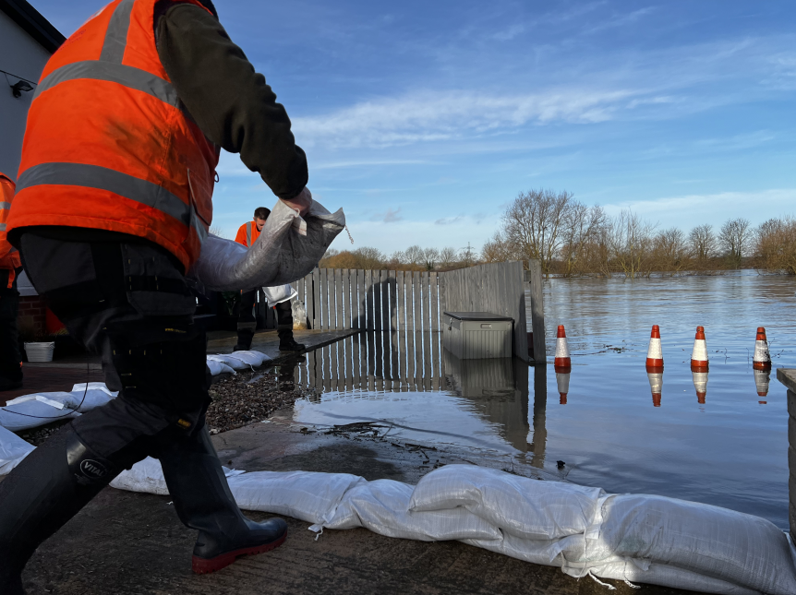
Officers work to contain flooding
During 2023/24, the Council reviewed its Customer Access Strategy which ensures the continuation of in-person customer contact points whilst simultaneously developing more ways that our residents can contact us online. Online licensing forms have also now become operational. Additionally, a range of innovative digital projects to increase the number of self-serve actions that residents can complete on our website has been delivered. This is alongside the use of technology internally to reduce waste and increase efficiency.
The move to bring street cleansing and ground maintenance functions back in-house via Streetwise in September 2022 has been a successful one and continues to help deliver financial efficiencies over the coming years, as profiled in the Council’s Transformation and Efficiency Programme. Market conditions and trading had become challenging, and the focus is on delivering key frontline services to Rushcliffe residents and not a wider range of services to residents outside of the Borough.
Five Council Leisure Centres are operated, including the state-of-the-art facilities in Bingham and West Bridgford. To keep progressing these such facilities, a £4.1m investment in refurbishments and energy upgrades to Cotgrave and Keyworth Leisure Centres was announced, partly funded by Salix grant income of £1.2m, with the delivery set to take place across the next two years. Working with a support grant from the Department of Levelling Up Housing and Communities, Cotgrave Leisure Centre and Gresham Sports Park have installed new Changing Places toilets to ensure greater access for people with mobility challenges to engage with sport at the sites.
For the third consecutive year the Council received a ‘Substantial’ overall opinion in its annual internal audit report in 2023/24 which is the highest level of assurance and is rarely awarded. This is a significant achievement particularly during continued challenging circumstances thus demonstrating the Councils positive culture for maintaining effective controls. The Council’s external auditors also approved the Council’s 2022/23 accounts including a positive opinion on the Council’s Value for Money.
Devolution, with the election of a Mayor of the East Midlands took place in May 2024. The long-term impact on Rushcliffe of devolution remains to be seen, but in the short term the expectation is it will impact upper tier authorities more significantly. We will continue to work with local authority partners to ensure we maximise opportunities for Rushcliffe residents.
Sustainable Growth.
The Council have continued to support the businesses of Rushcliffe, not least through the Rushcliffe Business Partnership working with the East Midlands Chamber, the Council provide free business support and advice for business owners across the borough and a free business high street advisor.
High Street Advisor supporting local businesses.
Work is ongoing on Freeport proposals for the development of East Midlands Airport, East Midlands Intermodal Park and Ratcliffe-on-Soar Power Station (decommissioning in September 2024). The Council is taking a proactive approach to secure the long-term future of the site via East Midlands Development Co (DevCo), the East Midlands Freeport and through the adoption of a Local Development Order (LDO) which grants planning permission for a range of modern industrial uses and will set the parameters for a site which is expected to provide innovative energy for the future.
The Council received £2.571m over three years (Capital and Revenue funding) from the UK Shared Prosperity Fund (UKSPF) for investment in local projects and £0.596m Rural England Prosperity Fund (and this is capital only). Schemes have commenced on both communities and place and business support projects. A grant funding pot for local organisations and local businesses was launched, awarding 21 businesses grants over two years. Through UKSPF joint commissioning for business support, East Midlands Chamber were appointed to deliver and support businesses across Rushcliffe and to date have engaged with around 120 businesses from across the borough via one-to-ones or workshop and training courses.
Meanwhile, the UKSPF joint commissioning for people and skills has supported the appointment of Nottinghamshire Futures to deliver support for local residents to access employment or training opportunities. This is alongside other support in place including skills funding, funded internship placements and a programme of training including low carbon, digital and ESOL (English for Speakers of Other Languages). UKSPF funding has also supported RBC’s new scheme to support community wellbeing projects in Rushcliffe with grants between £500 and £5,000 to tackle cost of living pressures, loneliness and isolation.
The Council continues to review its existing assets to ensure they remain fit for purpose reports this biennially to both Cabinet and the Governance Group with the last report in February 2024.
The Environment.
The Council’s Climate Change reserve created in 2020 has been utilised for a number of projects including:
- Green technology measures at the new build Bingham Arena and Rushcliffe Oaks Crematorium delivering 78% and 80% less carbon respectively
- CENEX fleet review, looking at alternative fuel sources including the transition to Hydrotreated Vegetable Oil for waste vehicles. 21 vehicles have been converted cutting carbon dioxide emissions by 90%, this will be further rolled out to other smaller vehicles during 2024/25.
- Electric car charging points at Rushcliffe County Park
Further initiatives have been delivered through external funding from a variety of sources including Home Upgrade Grants, Local Area Delivery Grants, Salix and OZEF (Office for Zero Emission Vehicles).
Rushcliffe Country Park (RCP) received its 17th consecutive Green Flag Award in January 2024, acknowledging the green space as one of the country’s best parks, whilst Sharphill Wood also received its first coverted Green Flag Award.
Rushcliffe Country Park received 17th consecutive Green Flag Award
Energy audits for ten council owned properties took place, with the Council now reviewing the recommendations and looking at possible quick and early wins in response. Low carbon business support and skills support is also being provided.
In partnership with the private sector, Waste Investigations Support Limited (WISE) have continued to enforce the full range of environmental crimes, keeping fly-tipping low and at zero cost to Council taxpayers. The Council tops the recycling and composting league in Nottinghamshire and the garden waste service continues to offer good value for money to over 30,000 subscribers.
The Council’s target is carbon neutral by 2030 for its operations and for the whole Borough by 2050. There is a detailed action plan with the Climate Change Reserve helping achieve this target. One challenge will be the future funding of carbon reduction schemes given other competing priorities and as the Climate Change Reserve reduces. The reserve has been topped up by £0.425m from 2023/24 underspends for carbon offsetting and there are plans to further increase this in 2024/25 using additional funding and New Homes Bonus to support this target.
The Council continues to proactively identify further suitable projects, and these will be put forward for approval for funding from the Reserve and include Photovoltaic (PV) panels on operational buildings, replacement heating plant and implementing recommendations from the fleet and infrastructure audit. A further £250k will be invested in solar energy at Cotgrave Leisure Centre on new solar panels to enable the site to run more efficiently whilst also saving up to £25k on running costs.
The Council’s budget is still delivering investment in further green projects and protection for residents from the impacts of flooding. In 2024/25, the Council will establish a Flood Grant and Resilience Reserve of £28k, to help local properties in flooding emergencies and address gaps in the current national guidance when the national flood scheme is in operation.
There are also policies on No-Mow areas to act as summer pollinator sites and encourage wildlife and habitats to thrive, expanding to 30 sites in May 2023 covering three hectares and the approved Public Space Protection Order which ensures dog owners must carry a bag. For the fifth year, the successful free tree scheme has seen the project supply over 1,000 further free trees to local residents and community groups, meaning more than 11,000 have to date been distributed as part of the Council’s strategy to provide sustainable environments. The Council approved a new policy providing further guidance on managing and protecting its trees and hedgerows that play a vital role in combatting climate change and enhancing wildlife, as well as implementing a new evaluation technique to help monitor and review green assets.
The policy will run until 2028. In line with Government legislation the Council is also delivering further biodiversity plans to help protect habitats for wildlife in new developments and nature recovery.
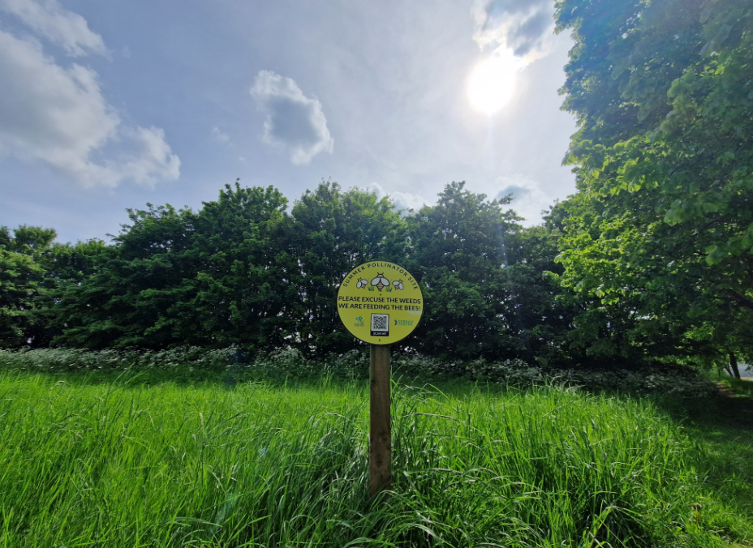
One of the many ‘No Mow’ sites in the Borough encouraging biodiversity
The Green Doctor programme which supports local residents, with funding from UKSPF, by providing energy efficiency advice and free energy efficiency items such as draught excluders is being continued into 2024/25.

- Financial Statements
The financial activities of the Council can be split between revenue and capital, and in general terms, the definitions are as follows: -
Income and expenditure within the revenue accounts of the Council relate to items consumed within the year; and
Income and expenditure within the capital accounts relate to items with a life in excess of one year.
The Council’s accounts consist of:
Comprehensive Income and Expenditure Statement - CIES (Page 2) - The net cost of service has increased by £0.588m. There have been a number of changes, most significantly Borough Council Elections held in 2023/24, a property related legal claim, increase in costs related to Toothill following the move to Bingham Arena partially offset by improved performance at Edwalton Golf Course.
The decrease in Other Operating Expenditure of £6.153m arises mainly from the gain from disposal of Sharphill overage £5.967m included in 2022/23.
The increase in Financing and Investment Income and Expenditure £3.457m relates to the favourable movements in Fair Value of Investment Properties £0.638m, the capital value of the Council’s Treasury Investments £1.728m, pension interest costs £0.348m (all technical in nature) and increased investment income £0.749m.
There is a favourable movement in Taxation and Non-Specific Grants of £1.584m in 2023/24 owing mainly to a release of Section 106 monies for Bingham Arena and Enterprise Centre £0.625m and an increase in Council Tax £0.530m due to growth in the taxbase and 2% increase in charge.
The movements above have resulted in an overall surplus on the Provision of Services of £1.669m compared to a surplus of £3.369m in 2022/23.
Revaluations on non-current assets has resulted in a decrease of £0.884m compared to an increase of £11.679m in 2022/23, when leisure centres benefited from significant increases in build cost indices and inflation.
There have also been pension adjustments changes in actuarial assumptions (Surplus of £5.077m compared to a surplus in the previous year of £43,420m) The 2022/23 actuarial gain (technical adjustment) was much higher as a result of the significant increase in discount rate which effectively reduced the value of the pension liability.
Movement in Reserves Statement (Page 3) – this shows the movement in the year of the different reserves held by the Council, analysed into ‘usable reserves’ (i.e., those that can be applied to fund expenditure) and ‘unusable reserves’ (those that an authority is not able to utilise to provide services).
Balance Sheet (Page 6) – This is a snapshot of the Council’s Assets, Liabilities and Reserves at the year-end date (31st March). The Council’s overall net worth has increased by £5.9m to £112.135m. In the year, the cash and cash equivalents have increased by £12.1m as a result of increase in Section 106 balances and underspends in the Capital Programme. The Pension Liability accounts reflects the valuations by the actuary and, as mentioned above, a change in actuarial assumptions with a net decrease of £5.3m in liabilities. Investment Property has decreased by £7.2m mainly due to the disposal of Hollygate Lane Agricultural Land, short term fixed investments have decreased by £1m this reflects movement between liquid and fixed term. Capital Grants Received in Advance have increased by £6.6m mainly due to new Section 106 contributions received in year of £16m net of £10m released to fund schemes in year.
The following graph shows the change in the Council’s net worth over the past ten years. Over the last ten years there has been a positive trend of an increase in net worth, the net worth has increased in 2023/24 to £112.135m. There is an inverse relationship between net worth and pension liability, in previous years (namely 2022/23) this is represented by a significant increase in net worth and a corresponding reduction in pension liability. The long-term assets include the investment properties and has reduced in 2023/24 due to the sale of Hollygate Lane as mentioned above.

Source: Balance Sheet

Cash-flow Statement (Page 7) – this shows the inflows and outflows of cash arising from transactions with third parties for revenue and capital purposes.
Notes (pages 9-49) – these provide supporting context to the above Statements.
Accounting Policies (Pages 50-68) – these explain the bases of the figures presented in the accounts.

- Supplementary Financial Statements
Collection Fund (pages 69-71) – this reflects the statutory requirement for the Council to maintain a separate account providing details of receipts of Council Tax and Business Rates and any associated payments to precepting authorities and central government. For 2023/24 there is a surplus of £0.356m on the Business Rates section of the Collection Fund (£0.1m 2022/23) and a surplus on Council Tax of £0.1m (deficit of £2m at the end of 2022/23) The surplus and deficit position fluctuates year on year as this is based on estimates for the year compared to the outturn position and the extent to which these differ.
- Summary
There is an increasing number of Councils under pressure from rising costs and the impact that the cost-of-living is having on Council income, and this is likely to continue to be a pressure in the future. The Council is not immune to these pressures and has continued to identify efficiencies during the year to balance the increased cost pressures and the outturn position shows a positive outcome in what is a very challenging economic environment. The Council has, and continues to face, many significant financial challenges. Delayed funding settlements and unexpected financial pressures (such as the War in Ukraine and recent troubles in the Middle East) which make financial planning challenging. In this volatile environment, a culture of prudence is essential, however, the Council has ambitions to deliver initiatives focusing on investment and growth in the community (including the opportunity of the Freeport) and this will stand the Council in good stead to meet both the operational and financial challenges it now faces. The Council must ensure it is prepared to face future financial pressures but also not lose sight of its longer-term agenda to ensure the Borough remains a great place to live, work and remain healthy; and for future generations that it has a sustainable environment. The Council has committed to meeting a net zero carbon emissions target and has topped up the Climate Change Reserve by £0.425m mainly to support the potential acquisition of land for carbon offsetting. Other pressures include the need to replace the Council’s finance and income systems and rising housing benefits costs; and appropriations to reservese from 2023/24 underspends have been made to ensure these can be achieved. Ongoing pay and energy cost inflation has placed a strain on the Council’s future finances and the Transformation and Efficiency Programme will require much vigour and some challenging decisions. A new Corporate Plan was approved in 2023 and the budget will continue to resource this, ensuring the principles of sustainability, prudence and affordability are maintained.
The Council is committed to delivering the services our residents value, economic growth, and change for the Borough through the delivery of its key strategies: from leisure to transformation. The Council will continue to be innovative (under much tighter constraints), so it continues to progress and provide better value for money for taxpayers. The Council will continue to aim to provide an environment to support both businesses and the community in these most challenging of times. At the forefront of economic growth in the longer term will be the role of both the Freeport and the opportunities these will create. Devolution is seen positively, viewed as an opportunity for enhanced local decision making that will support growth, improvement and to protect the vulnerable. The challenges that face Rushcliffe are ones which both members and officers of the Borough Council are determined to meet.

- Further Information
Further information about the Statement of Accounts is available from the Financial Services section at the Rushcliffe Arena, Rugby Road West Bridgford, Nottinghamshire NG2 7YG, telephone 0115 9819911 or by e-mail: finance@rushcliffe.gov.uk. In addition, members of the public have a statutory right to inspect the accounts before the annual audit is completed. The availability of the accounts for inspection is advertised on our website at www.rushcliffe.gov.uk.
Peter Linfield
Director - Finance and Corporate Services
31st May 2024

B. ANNUAL GOVERNANCE STATEMENT 2023/24
1. SCOPE AND PURPOSE
1.1 Scope of responsibility
Rushcliffe Borough Council is responsible for ensuring that its business is conducted in accordance with the law and proper standards, that public money is safeguarded and properly accounted for, and used economically, efficiently and effectively. Rushcliffe Borough Council also has a duty under the Local Government Act 1999 to make arrangements to secure continuous improvement in the way in which its functions are exercised, having regard to a combination of economy, efficiency and effectiveness.
In discharging this overall responsibility, Rushcliffe Borough Council is responsible for putting in place proper arrangements for the governance of its affairs, facilitating the effective exercise of its functions which includes arrangements for the management of risk.
Rushcliffe Borough Council has approved and adopted a code of corporate governance which is consistent with the principles of the CIPFA/SOLACE Framework Delivering Good Governance in Local Government (2016). The seven principles (A-G) are highlighted at various points within the statement. This statement explains how Rushcliffe Borough Council has complied with the code and also meets the requirements of regulation 4(2) of the Accounts and Audit Regulations 2003 as amended by the Accounts and Audit (Amendment) (England) Regulations 2006, 2011 and 2015, in relation to the publication of a statement on internal control.

1.2 The purpose of the governance framework
The governance framework comprises the systems, processes, culture and values, by which the authority is directed and controlled and the activities through which it accounts to, engages with and leads the community. It enables the authority to monitor the achievement of its strategic objectives and to consider whether those objectives have led to the delivery of appropriate, cost-effective services.
The system of internal control is a significant part of that framework and is designed to manage risk to a reasonable level. It cannot eliminate all risk of failure to achieve policies, aims and objectives and can, therefore, only provide reasonable, and not absolute, assurance of effectiveness. The system of internal control is based on an on-going process designed to identify and prioritise the risks to the achievement of Rushcliffe Borough Council's policies, aims and objectives, to evaluate the likelihood of those risks being realised and the impact should they be realised, and to manage them efficiently, effectively and economically.
The governance framework has been in place at Rushcliffe Borough Council for the year ended 31 March 2024 and up to the date of approval of the statement of accounts.

2 THE GOVERNANCE FRAMEWORK
Principles C & D – Defining outcomes in terms of sustainable benefits (economic, social and environmental) and determining interventions to achieve them

2.1 Vision and priorities
Long term strategic planning has enabled Rushcliffe to address its immediate financial pressures, develop a medium-term financial strategy to 2028/29 and an updated Corporate Strategy covering the period 2024 to 2027. The document is a ‘living strategy’ – one which will grow and evolve over its lifespan to adapt to the change needs of the authority. The four key priorities, contained within the Strategy, are:
- Quality of Life
- Efficient Services
- Sustainable Growth
- The Environment.
The integration of service and financial planning continues year on year and is resourced by the financial strategy.
The Council continues to work towards the delivery of its Transformation and Efficiency Strategy, its plan to address the financial pressures facing all public bodies. This also incorporates the Council’s Productivity Plan (a requirement introduced by Government as part of the 2024/25 financial settlement). This outlines how the Council will meet its financial challenges until 2028/29. The Transformation and Efficiency Strategy focuses upon three key elements – income generation, transformation and business cost reduction and aligns to the Productivity requirements (Service Transformation, Technology and Reducing Waste). As part of the transformation process, the Council is continuously reviewing the services it provides to identify improved or alternative methods of delivery which will enable it to meet its financial targets without eroding the high quality of service for which Rushcliffe is known.
All key tasks within the current service delivery plans have been linked directly to the Council’s strategic objectives.

2.2 Improvement and Efficiency
As with other public bodies, the Council continues to face significant financial pressures. The 2024/25 Medium Term Financial Strategy (MTFS) predicts a net budget deficit over 5 years of £1.6m (4% of annual gross expenditure) and whilst this can comfortably be accommodated from reserves in the short term, the Council’s priority will be to identify and deliver robust plans to transform processes and deliver efficiencies; and focus on opportunities to grow the Borough and manage the impact of growth and the changing socio-political, financial and environmental climate. The impact of both the Ukraine and Middle East conflicts continue to create much economic uncertainty impacting particularly on fuel and energy prices. Whilst pay increases are expected to decline, the salaries base budget has increased significantly over the past 3 years. This undoubtedly presents risk to the Council’s budget position. That said the Council has a Contingency budget of £0.3m and will look to any further revenue budget efficiencies to support budget pressures. Other pay and service challenges arise from the ability to attract and retain staff. Inflation does have an impact on who we trade with which in turn impacts supplies and services, transport and premises budget lines.
A combination of cost control and income generation and better than expected local economic performance and increased Nottinghamshire Business Rates Pool Surplus linked to prudent management of the Council’s finances, resulted in a projected budget efficiency position in 2023/24 (at Quarter 3) of £0.665m for 2023/24 mostly as a result of Business Rates Pool surplus and additional grants received. This represents a variance of 4.53% of Net Service Expenditure. Much of which is committed with carry forward requests to meet service challenges. Going forward there remain significant financial risks, and these are commented on below. Use of the Organisational Stabilisation reserve will ensure the Council continues to deliver its main corporate objectives. The impact of ongoing high inflation linked to both rising employee and energy costs means the trajectory of economic recovery remains uncertain and will continue to be closely monitored along with the associated changes to the Council’s projected financial position.
Going forward, the Council will review the Transformation Programme (Productivity Plan) as part of its ongoing financial governance arrangements. The Business Rates, Fair Funding and New Homes Bonus reviews continue to be delayed and it is anticipated now that these will not come to fruition until 2026/27, at the earliest and revised assumptions are reflected in the MTFS.
The budget will still focus on the following thematic areas to be balanced in future years:
- Service Efficiencies – focusing on both the customer and streamlining services;
- Management budget control – challenging base budgets each year;
- Transformational Projects – projects such as a new crematorium, Bingham leisure hub facilities and bringing Streetwise back in-house; and
- ‘Thinking big’ reviews – the emergence of the Development Corporation and Freeport area around Ratcliffe-on-Soar power station.
To secure a medium-term financial position, the Council will maintain progress and focus on managing budget reductions where appropriate, managing inflationary pressures on its operational costs, whilst increasing income to deliver balanced budgets annually. Areas of focus in 2023 included performance of the crematorium and streetwise as in-house service; and areas of risk and opportunity such as investment returns and that income levels are maintained given the impact of the cost-of-living crisis on individuals disposable income and therefore their ability to spend on Council services. In terms of expenditure the impact of inflation on both revenue and capital budgets continues to be monitored.
The Council continues to promote a commercial culture, although the Council has taken the strategic decision to realign its financial commitments focusing on investment in significant assets such as the Bingham Leisure Hub and the Crematorium and no longer investing in commercial assets for a financial return. The Council’s Capital and Investment Strategy incorporates reporting on existing commercial investments. Over the term of the MTFS, the income generated from such investments is estimated to rise from circa £1.9m (2024/25) to £2m (2028/29) and performance is reported to Governance Scrutiny Group throughout the year. The Council no longer invests in assets specifically for a commercial return.

2.3 The Constitution
Principle A - Behaving with integrity, demonstrating strong commitment to ethical values, and respecting the rule of law

A comprehensive document detailing the Council’s constitution clearly sets out the defined structure for the Council’s organisational arrangements based upon a cabinet executive model. In essence, the different roles can be summarised as follows:
- Council decides upon certain policies and other specialist functions that cannot be delegated elsewhere, including the setting of the council tax;
- Cabinet is allocated authority by Council to take executive decisions and approve policies not reserved for consideration by Council. Cabinet and Council works to a Forward Plan of forthcoming decisions for up to three months ahead;
- The work of Cabinet has been supported by four scrutiny groups. The Council now has a Corporate Overview Group, which manages corporate performance and financial control as well as the work programmes for the three additional scrutiny groups of Governance, Growth and Development, and Communities;
- Separate committees exist for Standards, Planning, Employment Appeals, Licensing, and Interviewing; and
- Delegation arrangements to officers are set out in detail within the Constitution.
The Constitution also provides detailed guidance on standing orders, financial regulations and the conduct of meetings. In addition, it contains codes of conduct applying to members and officers as well as a protocol for councillor/officer relationships. The codes include reference to the need to declare any interests which may conflict with the individual’s role at the Council. The registers for councillors and officers are maintained by the Council’s Monitoring Officer and the Strategic Human Resources Manager respectively. The Council has in place a confidential reporting code (whistleblowing policy) and any referrals under the policy are investigated.
The Constitution, as a whole, is reviewed when necessary and appropriate. The last review was in July 2023 and a further review is planned in 2024 reflecting procurement legislation changes.

2.4 Policies, Procedures, Laws and Regulations
The Council has three statutory officer roles: the Head of Paid Service, the Section 151 Officer, and the Monitoring Officer. The Chief Executive is the Head of Paid Service and has overall corporate management and operational responsibility including overall management responsibility for all officers. The Chief Executive has the special responsibility to report if insufficient resources are available for the Council to discharge its legal duties. The Monitoring Officer ensures lawfulness and fairness in decision making and ensures the Constitution is current.
The Section 151 Officer is specifically responsible for the proper discharge of financial arrangements and must advise the Council where any proposal might be unlawful or where expenditure is likely to exceed resources.
The Council’s financial management arrangements should conform with the governance requirements of the CIPFA Statement on the Role of the Chief Finance Officer in Local Government (2010). During 2023/24, the Council’s financial management arrangements complied in all respects with the governance requirements of the aforementioned statement, in particular:
- During 2023/24, the Director Finance and Corporate Services held the post of Chief Finance Officer. The post holder is a professionally qualified accountant with direct access to the Chief Executive, Leader of the Council and other Cabinet members. The post holder also has direct access to the Governance Scrutiny Group and the Council’s internal and external auditors.
- The Chief Finance Officer has a line of professional accountability for all finance staff and for ensuring that the finance function is ‘fit for purpose’. The Council has established robust arrangements to manage its finances, including a Medium-Term Financial Strategy, annual budget process and compliance with CIPFA’s Codes and Guidance on the Prudential Framework for Capital Finance, Treasury Management and the management of reserves.
- Internal audit services are provided to the Council by BDO. The effectiveness of this service is monitored by the Governance Scrutiny Group.
- The Chief Executive and three Directors are responsible for ensuring that legislation and policy relating to service delivery and health and safety are implemented in practice. Oversight of these arrangements is provided by the Director Neighbourhoods.

2.5 Risk Management

Principle F – Managing risks and performance through robust internal control and strong public financial management

The Council’s risk management arrangements are regularly reviewed. In the last twelve months, the Governance Scrutiny Group reviewed the Risk Register twice, in September 2023 and February 2024. At the last meeting in February there were 38 corporate risks and 27 operational risks on the risk register. In addition, there were 4 opportunity risks.
The Council also reports on risk as part of its reporting framework to Full Council, Cabinet and Scrutiny.
Risk managers have worked to evaluate risk descriptions as proposed by Zurich in the Risk Health Check in 2020. This work is complete, and the exercise resulted in new risks being identified and old risks being removed and reported and agreed by Governance Scrutiny Group. The next report in autumn 2024 will contain the new risks and reworded risk descriptions, building on the Council’s focus to address the ongoing impact of the cost-of-living and inflationary pressures, compounded by national living wage increases and pay negotiations.

2.6 Development and training needs
Principle E – Developing the council’s capacity including the capability of council leadership and staff
The Council has a cross party Member Development Group (MDG) to oversee the development and delivery of Councillor learning and training. This Group meets to review the delivery of the annual training programme and looks at the Councillors’ Community Grant Scheme before each election.
Learning and Development is an essential part of being a Councillor. The Council adopted a Councillors’ Learning and Development Policy in July 2021, and the Councillor Induction Programme is a vital element of that Policy.
The Induction Programme consisted of an Induction Handbook, three targeted sessions over the ten days following the Borough Elections in May 2023, together with details of an extensive training programme for the year, which was delivered in-person, virtually and via the Council’s e-learning platform.
A number of topics were mandatory to allow Councillors to be able to sit on committees, including planning, licensing and standards, together with courses on GDPR, understanding local government finance, risk management, motions at Council and scrutiny. Councillor Individual Training Records continue to be updated and periodically sent to each Councillor for their information.
During 2023/24, the MDG met twice to evaluate the Induction Programme, the training programme for the year and the development of the programme for 2024/25.
The identification and delivery of appropriate training for officers is overseen by the whole of the Executive Management Team who ensure that organisational Learning and Development Plans linking to individual annual Performance Development Reviews are effectively managed and delivered. The Council recognises the importance of training to its workforce.
2.7 Communication
Principle B - Ensuring openness and comprehensive stakeholder engagement
Rushcliffe Reports magazine – the Council’s newsletter for residents – was circulated to over 52,000 households on two occasions and a digital update to the growing online audiences, setting out key updates on a new leisure centre opening, popular music, food and children’s events and request feedback on the Corporate Strategy and its priorities.
Further projects including a refreshed Communication and Engagement Strategy are responding to the evolving to picture building on the three yearly resident’s survey feedback received in 2021, particularly across the Council’s digital channels to build on 84% of respondents being satisfied, or very satisfied, with their local area as a place to live, 2% higher than the Local Government Association national survey.
In a more hybrid and digital driven era, the Council has continued strong regular updates through developing effective relationships with the local media matched with tailoring relatable content on its social media channels to its key demographics to engage more subscribers across, passing 20,000 followers on all channels.
During 2023/24, the Council continued developing its electronic free subscription newsletter to stakeholders with the launch of a dedicated Garden Waste update to service users, another communication method that now sees over 18,000 residents gardening hints, tips and updates on the service direct to their inbox.
Customer satisfaction surveys continued with key customer facing services such as the Home Alarms service. The latter received a 100% satisfaction rating from users for an eighth consecutive year. The feedback received from these exercises will continue to be used to improve services to all customers. 2.8
  - Partnerships
The Council has put in place strong governance arrangements around the major leisure services, garage services, and car parking contracts. We have also entered into a partnership to improve resilience surrounding procurement advice working with Nottinghamshire County Council. Work continues with regards to the Freeport with the Leader of the Council sitting on the Board for the Freeport.
Ratcliffe on Soar Power Station is due to be decommissioned by 2025. This could have a significant impact on the Borough both financially (loss of business rates) and with the potential to have a very large derelict site at the entrance to the Borough from the A453. The role of the Freeport is critical with regards to this key gateway into the Borough. The East Midlands Freeport was approved by the Government on 30 March 2023. It will receive up to £25million in seed funding from the government to help drive investment in local businesses. The Freeport presents great opportunities for a world-class green and blue environmental investment programme with research and development in climate change and zero carbon technology and will enable employment opportunities and infrastructure investment.
The Chief Executive of the Council is a Director of the Development Corporation (DevCo) an interim vehicle to help deliver development of the power station site. The Council has committed £0.5m (an earmarked reserve) to support the Development Corporation with contributions from North West Leicestershire, Broxtowe Leicestershire and Nottinghamshire councils. The Leader sits on the Oversight Authority.
The Council is involved in the Devolution Deal proposals with other Derbyshire and Nottinghamshire authorities. With the East Midlands Mayor now in situ, from May 2024. Current proposals would still mean Rushcliffe as a Borough will retain its sovereignty, although there is a clear direction of travel for Councils to work more collaboratively for the benefit of their local communities.

2.9 Transparency
Principle G – Implementing good practice in transparency, reporting and audit to deliver effective accountability

All reports to meetings of Council, Cabinet, Scrutiny Groups and other committees are publicly available on the Council’s website. Minutes are also published providing a record of the meeting and any decisions taken, and the Council provides public access to audio and video recordings of meetings. Other forms of public accountability reporting include the Annual Statement of Accounts, the Council’s Annual Report and in-year financial and performance monitoring reports which are reported to the Governance Scrutiny Group and Corporate Overview Group respectively. Reports from the Council’s internal auditors (BDO) and external auditors (Mazars) are published online, including their annual reports.
The Corporate Overview Group monitor performance against targets on a quarterly basis. BDO are compliant with the requirements of the Public Sector Internal Audit Standards and has direct access to councillors and staff in order to discharge their duties.
The Council publishes information in accordance with the Local Authorities (Data Transparency) Code.

3 REVIEW OF EFFECTIVENESS
3.1 Introduction
Rushcliffe Borough Council has responsibility for conducting, at least annually, a review of the effectiveness of its governance framework including the system of internal control. The review of effectiveness is informed by the work of the senior managers within the authority who have responsibility for the development and maintenance of the governance environment, the Head of Internal Audit's annual report, and also by comments made by the external auditors and other review agencies and inspectorates. This review is considered by the Governance Scrutiny Group.

3.2 The Council
The Council approves and keeps under regular review all the strategic policies which it reserves for its own consideration, including:
- The Constitution
- The Corporate Strategy
- The Capital Programme and Revenue Budget
- The Housing Strategy
- The Local Development Framework
- The Capital and Investment Strategy

3.3 The Cabinet
The Cabinet carries out the executive functions of the Council as required by the legislation and the Council’s constitution. It accordingly:
- Takes key decisions
- Takes other executive decisions
- Approves policies other than those reserved for Council
- Recommends to Council policies and budgetary decisions.
3.4 Scrutiny groups - Governance Scrutiny Group

The Governance Scrutiny Group is charged with Governance and has a number of responsibilities including:
- Overseeing financial governance arrangements
- Overseeing strategic risk management
- Scrutinising the Annual Governance Statement
- Scrutinising the Statement of Accounts
- Reviewing the plans and work of Internal Audit
- Overseeing the review of the Constitution
- Receiving reports from external audit in relation to the audit arrangements
- Scrutinising the Going Concern report.

3.5 Other Scrutiny Groups
The Corporate Overview Group reviews the performance of the Council against the approved targets. Other reports are taken to this group and during the last year include the diversity annual report, annual customer survey and the health and safety reports.
In addition to the Corporate Overview Group and Governance Scrutiny Group, the Council has two other scrutiny groups. The first, Communities, looks at areas that affect the community, topics covered include are as diverse as East Midlands Airport, Social Housing Models, and Smoke Control Areas. The other group, Growth and Development, is tasked with looking at different aspects of growth within the Borough and has, this year for example, scrutinised reports in relation to Development and Infrastructure and Connectivity and Communications.

3.6 Directors
The Chief Executive and Directors are responsible for ensuring proper standards of internal control within their service areas. On-going reviews are undertaken throughout the year. At the end of the financial year, the Chief Executive and Directors are required to confirm that they have reviewed the system of internal control and identify any areas where improvements are necessary.

3.7 Internal Audit
Internal Audit is responsible for the review of the systems of internal control and for giving an opinion on both the corporate and service specific standards in place. BDO this year had their contract extended until 2027/28. An Audit Strategy has been developed covering all activities of the Council at a level and frequency determined using a risk management methodology.
An annual audit plan governs each year’s activity and at the completion of each audit, a report is produced for management with recommendations for improvement. Regular reports covering internal audit activities are submitted to the Governance Scrutiny Group for scrutiny.
The Head of Internal Audit is required to provide an annual opinion on the overall adequacy and effectiveness of the Authority’s framework of governance, risk management and control, together with reasons if the opinion is unfavourable.
At the time of writing, we are awaiting the Internal Audit report.

3.8 External Audit
The external auditors, Mazars, review the Council’s arrangements for:
- Preparing accounts in compliance with statutory and other relevant requirements;
- Ensuring the proper conduct of financial affairs and monitoring their adequacy and effectiveness in practice; and
- Managing performance to secure economy, efficiency and effectiveness in the use of resources.
The auditors give an opinion on the Council’s accounts, corporate governance and performance management arrangements. The Council takes appropriate action where improvements need to be made. Mazars issued an unqualified audit opinion, expressing the view that the financial statements give a true and fair reflection of the financial position of the Authority, and of its expenditure and income for the year. Whilst this was later than expected, with the accounts signed-off in December 2023 we are in a better position than many authorities with some several years behind regarding their financial statements being certified. We continue to work with the auditors to ensure the end of September deadline is met. A positive Value For Money conclusion was given by Mazars in their February report.

4 IMPORTANT GOVERNANCE ISSUES
4.1 Issues Identified, Budget and Ongoing Pressures and Inflation, the Peer Review, the CIPFA Financial Management Code, and other issues and proposed remedial action

Current budget position
2023/24 and 2024/25 budgets are again under pressure due to expenditure pressures in relation to energy and pay inflation. We are anticipating budget efficiencies for 2023/43 of around £1.66m mainly due to additional business rates income. This is not unexpected and will meet service pressures such as in relation to the ‘homes for Ukraine’ scheme and ‘safer streets’ funding. There are also anticipated additional pressures in relation to Finance and income System replacement and a commitment to increase the Climate Change Reserve for bio-diversity net gain.

The CIPFA Financial Management Code
The Chartered Institute of Public Finance & Accountancy (CIPFA) introduced a new code, The Financial Management Code 2019 (FM Code), which sets the standards of financial management for local authorities.
As we said we would do, we have asked a neighbouring authority to review the Council’s self-assessment and this is assessment is given at Appendix A. The approach used is to give a RAG rating and has also been reviewed by the Council’s Section 151 Officer. In summary, the findings of the current self-assessment against the Financial Management Standards gives a green rating against each standard.
The Peer Review and Other Issues
The Council had a Corporate Peer Review in early 2024. This was largely very positive with no significant issues identified. Recommendations were made and reported to Cabinet along with an Action Plan and/or comments in relation to the recommendations. The Peer Challenge Team will be reviewing progress in relation to the Action Plan in the Autumn of 2024.

Given all of the challenges linked to rising inflation combined with medium-term uncertainty for example as a result of Business Rates and Fair Funding reviews, the Council has balanced its budget. However, there is the challenge of £1.25m of efficiencies to be identified over the next 2 years, taking into account the £1.7m efficiencies in the Transformation Programme. The Transformation Strategy and supporting Programme identifies the Council’s approach to meeting its efficiency requirements and dovetails with the Council’s Productivity Plan (an ‘ask’ regarding the 2024/25 financial settlement). Whilst the expectation is pay and utility inflation will reduce, the base budget is already substantially inflated. Pay inflation is linked largely to government policy on the national minimum living wage but also labour market pressures generally affecting recruitment. There is also a knock-on effect on supplies and service costs, and we are already aware of cost pressures arising above and beyond those already in the budget. Fortunately the Council’s robust current financial position, at least in the short term, enables some mitigation regarding such cost pressures.

Going forward, there will also be service based pressures linked to statutory changes in relation to planning (Levelling-Up Act) and waste services (Simpler Recycling and the Environment Act) with details on guidance and funding being drip-fed from Government. This is a risk to both service provision and the budget going forward. The Council will, therefore, be making representation to relevant bodies and working with peers on how to mitigate this risk. Further information from Government is expected over the coming months.

The Council is still committed to having a commercial ethos and maximising value for money for the benefit of its residents. The Council has a range of income streams and manages such risks proportionately and sensibly. Under CIPFA guidance it cannot borrow to fund commercial activity.

The planned reviews of Business Rates and Fair Funding continue to be delayed. The current expectation is that they will be delayed until at least 2026/27, given the likelihood of a late General Election which creates more uncertainty regarding the timeliness of the 2025/26 financial settlement. New Homes Bonus has already been subject to consultation in 2021, as yet there has been no feedback from Government as to its future.
In the past we have referenced the risk of power station appeals. However given the reduction in business rates for the power station over time, the income has been eroded and its loss is now less of a risk. Business rates for the power station have reduced to around £0.8m (50% retained by central government) from £6m several years ago. The upside risk is that the Council’s future exposure to a power station appeal will have a smaller impact and similarly when the power station is ultimately de-commissioned its financial impact will not be as greatly felt.
The external auditors have noted a number of risks in their Audit Strategy Memorandum 2023/24 (which are similar to their 2022/23 Memorandum), namely:
- Appropriate controls are in place to prevent ‘management override’;
- The completeness and accuracy regarding the Council’s valuation of property, plant and equipment; and
- The Local Government Pension Scheme and the risk that the data is inaccurate and the impact of these inaccuracies on the financial accounts.
It is recognised that ICT threats and opportunities continue to evolve, it is imperative that the Borough Council has a clear understanding of how these impact on our day-to-day operations, particularly in the light of recent global cyber security threats. The Council continues to look at ensuring systems are hosted in ‘the cloud’ to mitigate such risks.
Despite the challenging economic environment, the Council remains committed to reducing its carbon footprint and continues to deliver excellent services. The Climate Change Reserve remains and with the challenge of delivering on biodiversity net gain targets and carbon offsetting, the Council continues to future proof this reserve to fund future initiatives.
Based on our review of the governance framework, the following significant issues will be addressed in 2023/24:
Issue | Reporting to | Methodology | Timescale
Monitor the delivery of the Transformation Strategy and ongoing budget position covering risks and opportunities arising from, for example, inflation, the new crematorium and Streetwise insourcing | Reports to EMT, Scrutiny and Cabinet | On-going financial reports | At least quarterly reporting
Monitor the delivery of the capital programme | Reports to Corporate Overview Group and Cabinet | On-going financial and performance reports | Quarterly
Monitor Business Rates, Fair Funding and New Homes Bonus developments | Reports to Cabinet and Full Council | Included as part of the Medium-Term Financial Strategy reporting; update to CGG as part of the AGS | By March 2025
Monitor the position with regards to significant external opportunities -Devolution, the Development Corporation and the Freeport | Reports to Cabinet and Full Council | On-going governance reports | By March 2025
5 STATEMENT OF THE CHIEF EXECUTIVE AND THE LEADER OF THE COUNCIL
We have been advised of the implications of the result of the review of the effectiveness of the governance framework by the Governance Scrutiny Group. The arrangements continue to be regarded as fit for purpose in accordance with the governance framework. The areas already addressed, and those to be specifically addressed with new actions planned, are outlined above.
We propose over the coming year to take steps to address the above matters to further enhance our governance arrangements. We are satisfied that these steps will address the need for improvements that were identified in our review of effectiveness and will monitor their implementation and operation as part of our next annual review.

Signed: Signed:
K Marriott (Chief Executive) Councillor N Clarke (Leader)
Date: September 2024 Date: September 2024

Appendix A
Financial Management Code Review
 | Financial Management Standard | Evidence and Comments | Risk Rating
Section 1: The Responsibilities of the Chief Finance Officer and Leadership Team
A | The leadership team is able to demonstrate that the services provided by the authority provide value for money. | Audit conclusion on 2022/23 accounts was the Council has put in place proper arrangements to secure economy, efficiency and effectiveness in its use of resources for the year ended 31 March 2023. General Fund reserve levels have been maintained above the minimum required level and the balance on other usable reserves is expected to reduce from £15m to £10m over the medium term. Despite inflation challenges excellent performance has been maintained (as per Finance and Performance reports) In year budgets 2023/24 are broadly on target. The Head Of Internal Audit’s audit conclusion is taken into consideration and comments included in the AGS if necessary. We comply with the requirements of the code
B | The authority complies with the CIPFA Statement on the Role of the Chief Finance Officer in Local Government. | CFO is CIPFA qualified with 34 years of local government experience; and reports to CEO; CFO role detailed in the Constitution; CFO sits on Executive Management Team, influencing material decisions and ensuring financial implications are provided in all reports. The CFO leads on corporate fraud. Through the Finance team treasury performance is monitored and reported to Governance Scrutiny Group throughout the year.
Section 2: Governance and Financial Management Style
C | The leadership team demonstrates in its actions and behaviours responsibility for governance and internal control. | BDO (internal audit report for 2022/23) The organisation has a substantial assurance framework for risk management, governance and internal control. Statement in the AGS in the STAC for 2022/23 demonstrating compliance. Accounts signed off by audit.
D | The authority applies the CIPFA/SOLACE Delivering Good Governance in Local Government: Framework (2016). | The Governance Group scrutinise Constitution changes and reviews the adequacy of Governance arrangements, such as risk management and approving the Annual Governance Statement. The Head Of Internal Audit’s audit conclusion is taken into consideration and comments included in the AGS if necessary.
E | The financial management style of the authority supports financial sustainability. | The Council has developed a Transformation Programme and made in excess of £5m in budget efficiencies with a further £1.7m planned. The Council monitors its Transformation and Efficiency Plan as part of monthly budget monitoring but this is also reported to COG and Cabinet as part of quarterly performance indicators and financial monitoring. It maintains a portfolio of commercial assets that generates just under £3m of income receipts annually. There are a sustained level of reserves commensurate with its risk appetite.
Section 3: Long to Medium-Term Financial Management
F | The authority has carried out a credible and transparent financial resilience assessment. | Budget setting for 2024/25 includes a statement from CFO that the estimates are robust. Budgets were set in conjunction with senior managers and members and appropriate challenge made. Budgets are balanced and reserves healthy and we have an achievable Transformation and efficiency plan monitored monthly. An independent review by consultants confirms the council has robust finances. Appendix A shows the 2021-22 CIPFA Resilience Index with relatively low risk. Independent benchmarking confirms this position. The Council has also participated in the LG Peer review in January 2024 and this concluded that the Council has a robust, current financial position, endorsed by its auditors. External and internal auditors were equally impressed with the Council's management of its finances and its responses to audit recommendations generally.
G | The authority understands its prospects for financial sustainability in the longer term and has reported this clearly to members. | We have a 5 year MTFS reported to Members and we have reported the authority’s position as a Going Concern. The Risk Register is constantly evolving and is updated as new risks emerge. Horizon scanning and discussions at Risk Management Group ensure that wider risks are considered. During 2024, the Council has conducted a Fraud Risk Assessment that will be reviewed by the Council’s internal auditors BDO.
H | The authority complies with the CIPFA Prudential Code for Capital Finance in Local Authorities. | Capital Strategy shows that plans are affordable prudent and sustainable – all PI’s are set and monitored, MRP is set to repay debt
I | The authority has a rolling multi-year medium-term financial plan consistent with sustainable service plans. | 5 year MTFS in place, projects and outcomes linked to corporate plan and proposals are scrutinised against the corporate plan and these feed into the departmental service plans. The Council will aim to review its capital plans over a longer time period to ensure future budgets are robust.
Section 4: The Annual Budget
J | The authority complies with its statutory obligations in respect of the budget setting process. | The Council complies with its statutory obligations in respect of the budget setting process as set out in the Local Government Finance Act (1992). A legal and balanced budget and corresponding Council Tax levels have been set by Council by the statutory deadline of 11 March and assurance has been provided by the CFO regarding the robustness of estimates and adequacy of reserve levels.
K | The budget report includes a statement by the chief finance officer on the robustness of the estimates and a statement on the adequacy of the proposed financial reserves. | The budget setting report comments upon the expenditure plans, reserves and risk and includes a statement from the CFO giving a positive assurance that the budget is balanced, robust and affordable
Section 5: Stakeholder Engagement and Business Plans
L | The authority has engaged where appropriate with key stakeholders in developing its long-term financial strategy, medium-term financial plan and annual budget. | Budget was made available to residents via Cabinet agenda prior to approval at Council. The MTFS resources the corporate Strategy which has been out for consultation to the residents of the Borough. Elected members given the opportunity to scrutinise and comment upon. Member workshops involve members at budget setting. We consult with Stakeholders on key projects e.g. Bingham Car Parking and the Crematorium.
M | The authority uses an appropriate documented option appraisal methodology to demonstrate the value for money of its decisions. | For capital investment appraisals and business cases the Council uses the agreed approach outlined in the Capital and Treasury Strategy and are subject to approval by Asset Investment Group. Projects that do not satisfy the set criteria (Net Present Value, Internal Rate of Return and impact on the General Fund and assessment matrix of non-financial criteria) are not approved in their current form. Specific appraisals are reported to Governance Group. Financial comments are required on reports to highlight and demonstrate consideration of financial impact and allow scrutiny of, and challenge to the proposals. The Council considers the impact on the climate of any investment or development proposals and actively seeks to ensure these are positive for the environment such as the new Crematorium and improvements to its Leisure Centres.
Section 6: Monitoring Financial Performance
N | The leadership team takes action using reports enabling it to identify and correct emerging risks to its budget strategy and financial sustainability. | Monthly reports are considered by budget holders, which is in turn reported to and scrutinised by Service Managers. Issues identified current concerns are reported to EMT. Quarterly Finance and performance reports are presented to Cabinet and COG. Reports include a section on financial implications, performance and risk. Monthly reports are sent to EMT on aged debt and outstanding items of concern. TM reports are taken quarterly and at year end to GSG and more detailed meetings are held monthly in the finance team. The finance officers involved in TM undertake regular training and treasury advisors deliver annual training for members
O | The leadership team monitors the elements of its balance sheet that pose a significant risk to its financial sustainability. | EMT are actively involved in budget workshops which demonstrates the position on Revenue, Capital and Reserves and sit at Full Council when the budget is approved
Section 7: External Financial Reporting
P | The chief finance officer has personal and statutory responsibility for ensuring that the statement of accounts produced by the local authority complies with the reporting requirements of the Code of Practice on Local Authority Accounting in the United Kingdom. | The CFO’s responsibilities are set out in the “Statement of Responsibilities” within the STAC. This statement clearly sets out that the CFO is responsible for the preparation of the Council’s Statement of Accounts in accordance with proper practices as set out in the CIPFA Code of Practice on Local Authority Accounting in the United Kingdom. The annual audit letter confirms that the 2022/23 STAC has been prepared in accordance with the code.
Q | The presentation of the final outturn figures and variations from budget allows the leadership team to make strategic financial decisions. | The outturn figures are reported to Cabinet and included in the narrative sections of the statement of accounts. Variances are clearly identified including highlighting those that are ‘accounting adjustments’. Use of underspends are clearly identified in the report, including carry forward requests and these are approved by Cabinet.

C. INDEPENDENT AUDITORS REPORT TO THE MEMBERS OF RUSHCLIFFE BOROUGH COUNCIL

To be added post audit of 2023/24 Statement of Accounts.
Statement of Accounts
2023 – 2024

D. STATEMENT OF RESPONSIBILITIES FOR THE STATEMENT OF ACCOUNTS
THE COUNCIL’S RESPONSIBILITIES
The Council is required to:
- make arrangements for the proper administration of its financial affairs and to secure that one of its officers has the responsibility for the administration of those affairs. In this Council, that officer is the Deputy CEO and Director (Finance and Corporate Services) hereafter called the Director.
- manage its affairs to secure economic, efficient and effective use of resources and safeguard its assets.
- approve the Statement of Accounts.
THE DIRECTOR (FINANCE AND CORPORATE SERVICES) RESPONSIBILITIES
The Director (Finance and Corporate Services) is responsible for the preparation of the Council’s Statement of Accounts in accordance with proper practices, as set out in the Chartered Institute of Public Finance and Accountancy’s “Code of Practice on Local Authority Accounting in the United Kingdom” (“the Code of Practice”).
In preparing this Statement of Accounts, the Director (Finance and Corporate Services) has:
- selected suitable accounting policies and then applied them consistently
- made judgements and estimates that were reasonable and prudent
- complied with the Code of Practice
The Director (Finance and Corporate Services) has also:
- kept proper accounting records which were up to date
- taken reasonable steps for the prevention and detection of fraud and other irregularities.
The Director (Finance and Corporate Services) should sign and date the Statement of Accounts, stating that it gives a true and fair view of the financial position of the Council at the accounting date and its income and expenditure for the year ended 31 March 2024.
CERTIFICATE
This statement of accounts is unaudited and may be subject to change prior to formal approval by the Governance Scrutiny Group.
I hereby certify that the following Statement of Accounts gives a true and fair view of the financial position of Rushcliffe Borough Council at 31 March 2024 and its income and expenditure for the financial year ended 31 March 2024.
Date:
Peter Linfield, Deputy CEO and Director - Finance and Corporate Services

E. THE FINANCIAL STATEMENTS

COMPREHENSIVE INCOME AND EXPENDITURE STATEMENT
FOR THE YEAR 1 APRIL 2023 TO 31 MARCH 2024
This statement shows the accounting cost in the year of providing services in accordance with International Financial Reporting Standards (IFRS), rather than the amount to be funded from taxation. Authorities raise taxation to cover expenditure in accordance with regulations; this may be different from the accounting cost. The taxation position is shown in the Movement in Reserves Statement.

E. THE FINANCIAL STATEMENTS

MOVEMENT IN RESERVES STATEMENT (MIRS)
This statement shows the movement in the year on the different reserves held by the Council, analysed into ‘usable reserves’ (i.e., those that can be applied to fund expenditure or reduce local taxation) and other reserves. The Surplus or Deficit on the Provision of Services line shows the true economic cost of providing the Council’s services, more details of which are shown in the Comprehensive Income and Expenditure Statement. These are different from the statutory amounts required to be charged to the General Fund Balance for council tax setting. The Net Increase/Decrease before Transfers to Earmarked Reserves line shows the statutory General Fund Balance before any discretionary transfers to or from earmarked reserves.

E. THE FINANCIAL STATEMENTS
MOVEMENT IN RESERVES STATEMENT (MIRS) FOR THE PERIOD 1 APRIL 2023 TO 31 MARCH 2024

MOVEMENT IN RESERVES STATEMENT (MIRS) FOR THE PERIOD 1 APRIL 2022 TO 31 MARCH 2023

E. THE FINANCIAL STATEMENTS

BALANCE SHEET
AS AT 31 MARCH 2024
This shows the value of the assets and liabilities recognised by the Council. The net assets of the Council (assets less liabilities) are matched by the reserves held by the Council. Reserves are reported in two categories. The first category of reserves are usable reserves, i.e., those reserves that the Council may use to provide services, subject to the need to maintain a prudent level of reserves and any statutory limitations on their use (for example the Capital Receipts Reserve may only be used to fund capital expenditure or repay debt). The second category of reserves is those that the Council is not able to use to provide services. This category of reserves includes reserves that hold unrealised gains and losses (for example the Revaluation Reserve), where amounts would only become available to provide services if the assets are sold; and reserves that hold timing differences shown in the Movement in Reserves Statement line ‘Adjustments between accounting basis and funding basis under regulations’.
*£0.521m Housing Benefit debtors reclassified as Short Term Debtors from Long Term Debtors £0.138m leaseholder deposits reclassified as Long Term Creditors from Long Term Provisions

E. THE FINANCIAL STATEMENTS

CASH FLOW STATEMENT
AS AT 31 MARCH 2023 (INDIRECT METHOD)
The Cash Flow Statement shows the changes in cash and cash equivalents of the Council during the reporting period. The statement shows how the Council generates and uses cash and cash equivalents by classifying cash flows as: operating, investing and financing activities. The amount of net cash flows arising from operating activities is a key indicator of the extent to which the operations of the Council are funded by way of taxation and grant income or from the recipients of services provided by the Council. Investing activities represent the extent to which cash outflows have been made for resources which are intended to contribute to the Council’s future service delivery. Cash flows arising from financing activities are useful in predicting claims on future cash flows by providers of capital (i.e., borrowing) to the Council.

E. THE FINANCIAL STATEMENTS

EXPENDITURE AND FUNDING ANALYSIS AND NOTES FOR THE YEAR 1 APRIL 2023 TO 31 MARCH 2024
The Expenditure and Funding Analysis shows how annual expenditure is used and funded from resources (government grants, rents, council tax and business rates) by authorities compared to resources consumed or earned by authorities in accordance with generally accepted accounting practices. It also shows how this expenditure is allocated for decision making purposes between the Council’s service areas. Income and expenditure accounted for under generally accepted accounting practices is presented more fully in the Comprehensive Income and Expenditure Statement.

F. NOTES TO THE ACCOUNTS

1. NOTES TO THE EXPENDITURE AND FUNDING ANALYSIS

Note 1a Adjustments for Capital Purposes
Net cost of services Line – this column adds in depreciation and impairment and revaluation gains and losses.
Other operating expenditure – adjusts for capital disposals with a transfer of income on disposal of assets and the amounts written off for those assets.
Financing and investment income and expenditure – the statutory charges for capital financing i.e., Minimum Revenue Provision and other revenue contributions are deducted from other income and expenditure as these are not chargeable under generally accepted accounting practices.
Taxation and non-specific grant income and expenditure – capital grants are adjusted for income not chargeable under generally accepted accounting practices. Revenue grants are adjusted from those receivable in the year to those receivable without conditions or for which conditions were satisfied throughout the year. The Taxation and Non-Specific Grant Income and Expenditure line is credited with capital grants receivable in the year without conditions or for which conditions were satisfied in the year.
Note 1b Net Change for the Pensions Adjustments
Net change for the removal of pension contributions and the addition of IAS 19 Employee Benefits pension related expenditure and income:
For services this represents the removal of the employer pension contributions made by the authority as allowed by statute and the replacement with current service costs and past service costs.
For Financing and investment income and expenditure – the net interest on the defined benefit liability is charged to the CIES.
Note 1c Other Differences
For Services Other differences between amounts debited/credited to the Comprehensive Income and Expenditure Statement and amounts payable/receivable to be recognised under statute i.e., Accumulated Absences.
Financing and investment income and expenditure – statutory reversal of fair value gains and losses on diversified/pooled investments.
The charge under Taxation and non-specific grant income and expenditure - represents the difference between what is chargeable under statutory regulations for Council Tax and NDR that was projected to be received at the start of the year and the income recognised under generally accepted accounting practices in the Code. This is a timing difference as any difference will be brought forward in future Surpluses or Deficits on the Collection Fund.

2. INCOME AND EXPENDITURE ANALYSED BY NATURE
The Council’s income and expenditure is analysed as follows:

3. ADJUSTMENTS BETWEEN ACCOUNTING BASIS AND FUNDING BASIS UNDER REGULATIONS
This note details the adjustments that are made to the total Comprehensive Income and Expenditure Statement recognised by the Council in the year in accordance with proper accounting practice to the resources that are specified by statutory provisions as being available to the Council to meet future capital and revenue expenditure.
The following sets out a description of the reserves that the adjustments are set against:
General Fund Balance
The General Fund is the statutory fund into which all the receipts of a Council are required to be paid and out of which all liabilities of the Council are to be met, except to the extent that statutory rules might provide otherwise. These rules can also specify the financial year in which liabilities and payments should impact on the General Fund Balance, which is not necessarily in accordance with proper accounting practice.
The General Fund Balance therefore summarises the resources that the Council is statutorily empowered to spend on its services or on the capital investment (or the deficit of resources that the Council is required to recover) at the end of the financial year.
Capital Receipts Reserve
This holds the proceeds from the disposal of land or other assets which are restricted by statute from being used other than to fund new capital expenditure. The balance on the reserve shows the resources that have yet to be applied for these purposes at the year end.
Capital Grants Unapplied
This holds the grants and contributions received towards the capital projects for which the Council has met the conditions that would have otherwise require repayment of the monies, but which have yet to be applied to meet expenditure. The balance is restricted by the grant terms as to the capital expenditure against which it can be applied and/or the financial year in which this can take place.

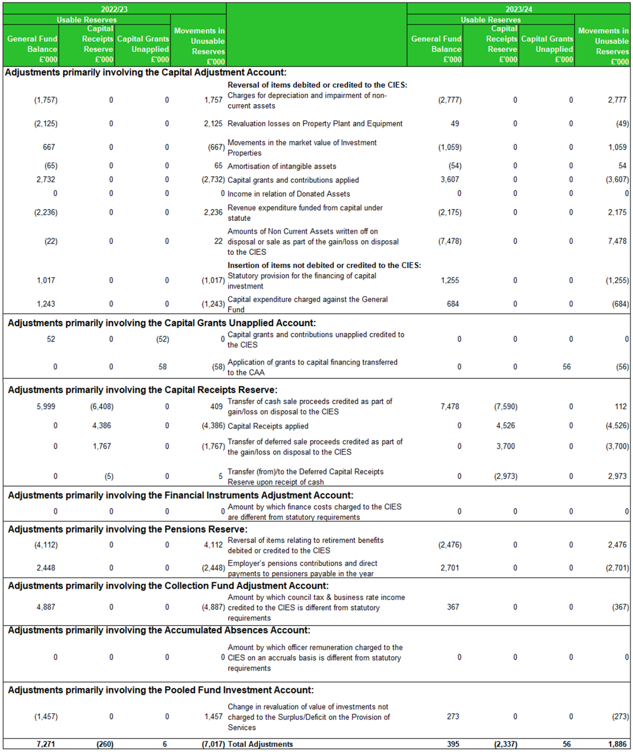

4. TRANSFERS TO/(FROM) EARMARKED RESERVES
This note sets out the amounts set aside from the General Fund Balance in earmarked reserves to provide financing for future expenditure plans and the amounts posted back from earmarked reserves to meet General Fund expenditure.
INVESTMENT RESERVES
- Regeneration and Community Projects – to provide funding to support capital improvement projects across the Borough including some special expense schemes.
- Investment Properties – to fund improvements.
- New Homes Bonus – to help facilitate growth within the Borough, not ring-fenced solely for housing projects.
CORPORATE RESERVES
- Organisation Stabilisation Reserve – to be used to provide resilience against risks surrounding the Medium-Term Financial Strategy.
- Climate Change Reserve – To support projects that contribute to the Council’s ambitions to protect and enhance the environment.
- Treasury Capital Depreciation Reserve – To provide funding to reduce the impact on the general fund from reductions in the capital value of treasury investments.
- Collection Fund Reserve – To smooth effects of surplus/deficits as a result of timing differences.
- Development Corporation – To support the work to establish a Development Corporation and Freeport.
- Risk and Insurance – to provide funding to be used to reduce the risk of loss or injury in the provision of services, with the objective of reducing future insurance costs.
- Planning Appeals – to provide funding to cover potential legal and other cost in respect of large applications.
- Elections – to provide funding for the future costs of the four yearly Borough Council elections.
OPERATING RESERVES
- Planning - to provide funding for one off revenue costs of the planning service, for example, legal costs, specialist advice and consultancy.
- Leisure Centre Maintenance – to support any emerging enhancement requirements which are over and above in-year maintenance provision.
- Vehicle Replacement Reserve – to support the replacement of the Council’s vehicle fleet to ensure services remain efficient and to support costs of replacement with potential new technology.

5. OTHER OPERATING EXPENDITURE
The composition of the Other Operating Expenditure line in the Comprehensive Income and Expenditure Statement is detailed below:
* £5.91m relating to overage for Sharphill Wood 2022/23

6. FINANCING AND INVESTMENT INCOME AND EXPENDITURE
The composition of the Financing and Investment Income and Expenditure line in the Comprehensive Income and Expenditure Statement is detailed below:

7. TAXATION AND NON-SPECIFIC GRANT INCOME AND EXPENDITURE
The composition of the Taxation and Non-Specific Grant Income line in the Comprehensive Income and Expenditure Statement is detailed below. Capital grants are higher in 2022/23 due to Green Energy Grants including; Salix and Home Upgrade (HUG).
The detailed breakdown of Grants is shown in Note 27.

8. PROPERTY, PLANT AND EQUIPMENT
Movements on Balances 2023/24

Movements on Balances 2022/23
8. PROPERTY, PLANT AND EQUIPMENT CONTINUED
Depreciation
The following useful lives and depreciation rates have been used in the calculation of depreciation:
- Buildings 5-100 years
- Vehicles, Plant Furniture and Equipment 3-30 years
- Infrastructure 3-50 years
Capital Commitments
At 31 March 2024, the Council was contractually committed to works totalling £2.489m for the acquisition, construction, and enhancement of property and grants to third parties in 2024/25. Significant items of contract and other costs comprise: Cotgrave and Keyworth Leisure Centre enhancements £1.5m; Disabled Facilities Grants £0.355m; Vehicle Acquisition £0.151m; and Greythorn Drive Play Area £0.102m.

Revaluations
In accordance with the Code of Practice, the Council carries out a rolling programme that ensures that all Property, Plant and Equipment required to be measured at fair value are re-valued at least every three years. The Council, as a consequence, will be revaluing a third of its Land and Buildings portfolio every year. Assets with a value greater than £1 million are revalued annually.
Valuations of land and buildings were carried out in accordance with the Royal Institution of Chartered Surveyors Valuation Standards (Red Book) 9th Edition. Every fair value valuation was carried out using the assumptions as set out in the Red Book. Where assumptions additional to those which are set out in the Red Book have been made these are stated on the relevant valuation certificates. Mr Nick Berry Senior Property Estates Surveyor is responsible for revaluation of property assets, signed off by the Council’s Director – Development and Economic Growth, Leanne Ashmore MRICS. An impairment review is carried out annually on the Land and Buildings portfolio.
Valuations of vehicles, plant, furniture and equipment are based on depreciated historic cost as a proxy for current prices. These assets have short depreciable lives.
All valuations were carried out internally. The following table shows the progress of the Council’s three-year rolling programme for the revaluation of fixed assets. These figures are shown at gross book value.

9. INVESTMENT PROPERTIES
The following items have been accounted for in the Financing and Investment Income and Expenditure line in the Comprehensive Income and Expenditure Statement.
There are no restrictions on the Council’s ability to realise the value inherent in its investment property or on the Council’s rights to the remittance of income and the proceeds of disposal.
The Council has no contractual obligations to repair, maintain or enhance investment properties.
The following table summarises the movement in the fair value of investment properties during 2023/24 and 2022/23.

9. INVESTMENT PROPERTIES CONTINUED
All of the Council’s Investment Properties are treated as operating leases.
Valuations of Investment Properties are carried out annually in accordance with the Code of Practice and with the Royal Institution of Chartered Surveyors (RICS) Valuation Standards (Red Book) 9th Edition. Every Fair Value valuation was carried out using the assumptions as set out in the Red Book. A Market Valuation technique has been used for all Investment Properties and they are all based on the level 2 input hierarchy. This means that values have been arrived at using evidence (other than quoted prices) in an active market and that this evidence is directly or indirectly observable. The inputs used include the following market analyses: rents, yields, lease terms, research on farmland values, and other market evidence and comparative data. Where assumptions additional to those which are set out in the Red Book have been made, these are stated on the relevant valuation certificates. Nick Berry, the Senior Property Surveyor completed the valuation exercise, and this was subsequently reviewed and signed off by the Director – Development and Economic Growth: Leanne Ashmore MRICS. An impairment review is carried out annually on the Investment Property portfolio.

10. INTANGIBLE ASSETS
The Council accounts for its software as intangible assets. All software is given a finite useful life, based on assessments of the period that the software is expected to be of use.
The useful lives assigned to the major software suites used by the Council are three years.
The carrying amount of intangible assets is amortised on a straight-line basis. The amortisation of £54k in 2023/24 (£65k 2022/23) was charged to the Information Technology cost centre within Finance and Corporate Service Area.
Movements on Intangible Fixed Assets
The Council had no contractual commitments for the acquisition of Intangible Assets at 31.3.24

11. ASSETS HELD FOR SALE
In accordance with IFRS 5, Property, Plant, and Equipment (PPE) assets held for sale are measured at the lower of carrying amount and fair value less costs to sell.
CIPFA code of Practice specifies that Investment Properties, which meet the classification criteria for assets held for sale, must continue to be accounted for as Investment Property and these are held at Fair Value. The Council has not elected to have a separate category within Investment Property for sale assets. At the Balance Sheet date, the Council held one Investment Property (Candleby Lane Industrial Estate) for sale subject to contract negotiations. Estimated sale proceeds circa £100k.

12. FINANCIAL INSTRUMENTS
The following categories of financial instruments are carried in the balance sheet.
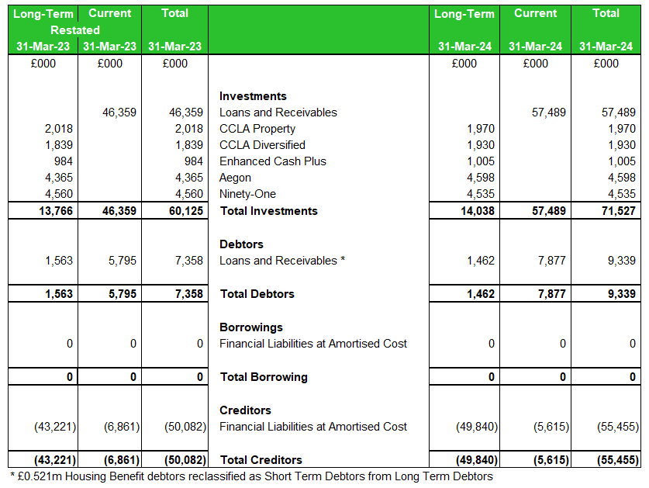
Valuation Assumptions
Investments held at 31 March 2024 amounted to £71.215m, consisting of £31m of fixed term investments where the instrument carries the same interest rate for the whole term, £26.177m of deposits in the Money Market and Call Account funds where, in general, the rate only alters with movements in the Bank rate, and £14.038m in funds valued at bid price for the shares which the Council holds. Cash and Bank included in total current investments are £0.312m No formal calculation of the effective interest rate (EIR) is necessary, and the carrying amount is a reasonable approximation of the fair value.
Debtors and creditors, both of which are instruments of short duration, with no formal effective interest rate (EIR) are at fair value.
An assessment has been made whether any impairment write-down or provisions previously made need to be reversed, or if any new ones need to be made. A full review of impairment provisions has been completed and appropriate adjustments to the provisions have been made on the age analysis of debtors involved.
Long Term Investments
The Council holds £14.038m in pooled fund investments. These are externally managed funds that invest in such things as equities, bonds, property, with different strategies, this adding diversification to RBCs portfolio.
These assets have to be held on the balance sheet at fair value reflecting instability in the financial market and volatility in net asset value (NAV). The pooled investments are held for the long-term so any losses are not realised, for this reason, the Council does not classify pooled fund investments as cash and cash equivalents.
Cash and cash equivalents are held for the purpose of meeting short-term cash commitments rather than for investment or other purposes. They must be readily convertible to a known amount of cash and be subject to an insignificant risk of changes in value (IAS 7 Para 6).
Pooled fund investments do not meet this definition. They are not used for the purpose of meeting cash flow commitments and are accordingly treated as long-term investments.

13. DEBTORS
* Housing Benefit debtors have been moved from long term to short term debtors

14. DEBTORS FOR LOCAL TAXATION
The past due but not impaired amount for local taxation (council tax and non-domestic rates)
within the total debtors’ figure is analysed below

15. CASH AND CASH EQUIVALENTS

16. CREDITORS
*Note restated to include Leaseholder Deposits as Long-Term Creditor

17. PROVISIONS
NDR Appeals
This provision sets aside sums for the Council’s element of anticipated appeals that may arise in respect of Business Rates. The full liability is expected to be approximately £2.225 million with Rushcliffe’s share at 40% and the difference is to be met by major preceptors - Central Government (50%), Nottinghamshire County Council (9%) and Fire Authority (1%).

18. USABLE RESERVES
Movements in the Council’s usable reserves are detailed in the Movement in Reserves Statement (MIRS) Page 3. There is a breakdown of Earmarked Reserves in note 4.

19. UNUSABLE RESERVES

Revaluation Reserve
The Revaluation Reserve contains the gains made by the Council arising from increases in the value of its Property, Plant and Equipment (and Intangible Assets). The balance is reduced when assets with accumulated gains are:
- revalued downwards or impaired and the gains are lost;
- used in the provision of services and the gains are consumed through depreciation; or
- disposed of and the gains are realised.
The Reserve contains only revaluation gains accumulated since 1 April 2007, the date that the Reserve was created. Accumulated gains arising before that date are consolidated into the balance on the Capital Adjustment Account.

Capital Adjustment Account
The Capital Adjustment Account absorbs the timing differences arising from the different arrangements for accounting for the consumption of non-current assets and for financing the acquisition, construction or enhancement of those assets under statutory provisions. The Account is debited with the cost of acquisition, construction or enhancement as depreciation, impairment losses and amortisations are charged to the Comprehensive Income and Expenditure Statement (with postings from the Revaluation Reserve to convert fair values to a historical cost basis). The Account is credited with the amounts set aside by the Council as finance for the costs of acquisition, construction and enhancement.
The Account contains accumulated gains and losses on Investment Properties that have yet to be consumed by the Council.
The Account also contains revaluation gains accumulated on Property, Plant and Equipment before 1 April 2007, the date the Revaluation Reserve was created to hold such gains.
Pensions Reserve
The Pensions Reserve absorbs the timing differences arising from the different arrangements for accounting for post-employment benefits and for funding benefits in accordance with statutory provisions. The Council accounts for post-employment benefits in the Comprehensive Income and Expenditure Statement as the benefits are earned by employees accruing years of service, updating the liabilities recognised to reflect inflation, changing assumptions and investment returns on any resources set aside to meet the costs. However, statutory arrangements require benefits earned to be financed as the Council makes employer’s contributions to pension funds or eventually pays any pensions for which it is directly responsible. General Fund balance to be charged with the amount payable by the Council to the pension fund in the year. The debit balance on the Pensions Reserve therefore shows a substantial shortfall in the benefits earned by past and current employees and the resources the Council has set aside to meet them. The statutory arrangements will ensure that funding will have been set aside by the time the benefits come to be paid.
Deferred Capital Receipts Reserve
This reserve holds the gains recognised on the disposal of non-current assets but for which cash settlement has yet to take place. Under statutory arrangements, the Council does not treat these gains as usable for financing new capital expenditure until they are backed by capital receipts. When the deferred cash settlement eventually takes place, amounts are transferred to the Capital Receipts Reserve.

Collection Fund Adjustment Account
The Collection Fund Adjustment Account manages the differences arising between the recognition of council tax income in the Comprehensive Income and Expenditure Statement as it falls due from council taxpayers compared with the statutory arrangements for paying across amounts to the General Fund from the Collection Fund.
Accumulated Absences Account
The Accumulated Absences Account absorbs differences that would otherwise arise on the General Fund Balance from accruing for compensated absences earned but not taken in the year, for example, annual leave entitlement carried forward at 31 March. Statutory arrangements require that the impact on the General Fund Balance is neutralised by transfers to/from the Account. The differences in amounts accrued are not deemed to be material and therefore no transactions have been made in 2023/24.

Pooled Funds Adjustment Account
The Pooled Funds Adjustment Account contains the gains made by the Council arising from increases in the value of its investments that are measured at fair value through Profit and Loss. The balance is reduced when investments with accumulated gains are:
- revalued downwards or impaired and the gains are lost
- disposed of and the gains are realised
The Council holds £13.766m of pooled investments. The Council is using the temporary statutory override agreed by DLUHC (5 years commencing from April 2018) to account for any changes in the fair value on its pooled investments. The statutory override was due to end 31 March 2023 but has been extended a further 2 years.

20. CASHFLOW STATEMENT – OPERATING ACTIVITIES

20. CASHFLOW STATEMENT – OPERATING ACTIVITIES CONTINUED
The cash flows for operating activities include the following items:

21. CASHFLOW STATEMENT – INVESTING ACTIVITIES

22. CASHFLOW STATEMENT – FINANCING ACTIVITIES

23. MEMBERS’ ALLOWANCES
The Council paid the following amounts to members of the Council during the year:

24. OFFICERS’ REMUNERATION
The remuneration paid to the Council’s senior employees is as follows:
The Council’s other employees receiving more than £50,000 remuneration for the year (Excluding Pension Costs) are as follows:

25. EXIT PACKAGES AND TERMINATION BENEFITS
The number of exit packages with total cost per band and total cost of the compulsory and other redundancies for 2023/24 are set out in the table below.
The Council terminated 4 contracts in 2022/23.

26. EXTERNAL AUDIT COSTS
The Council has incurred the following costs in relation to audit services provided by the Council’s appointed external auditors.
27. GRANT INCOME
The Council credited the following grants, contributions and donations to the Taxation and Non-Specific Grant Income line (Note 7) in the Comprehensive Income and Expenditure Statement in 2023/24 and 2022/23.

27. GRANT INCOME CONTINUED
The following grants, above £50,000, were credited to services.
The Council received grants, contributions and donations not yet recognised as income as they have conditions attached to them that will require the monies or property to be returned if the conditions are not met. The balances at year end are as follows:
The Council received the following capital grants receipts in advance:

The Council received the following revenue grants receipts in advance

28. RELATED PARTIES
The Council is required to disclose material transactions with related parties, bodies or individuals that have the potential to control or influence the Council or to be controlled or influenced by the Council. Disclosure of these transactions allows readers to assess the extent to which the Council might have been constrained in its ability to operate independently or might have secured the ability to limit another party’s ability to bargain freely with the Council.
Central Government
Central Government has significant influence over the general operations of the Council. It is responsible for providing the statutory framework within which the Council operates, provides funding in the form of grants and prescribes the terms of many of the transactions that the Council has with other parties (e.g., council tax bills, housing benefits). Grant receipts above £50,000 are shown in Note 27.
Members
Members of the Council have direct control over the Council’s financial and operating policies. The total members allowances paid in 2023/24 are shown in Note 23. The Members could potentially have a material related party transaction with the Council. During 2023/24 the Council, in accordance with the National Code of Local Government Conduct, maintained a register of pecuniary and non-pecuniary interest disclosed by members. During the year 2023/24 the following amounts were transacted with related parties: A contract totalling £50,000 was awarded from UKSPF funding in 2024/25 to a local provider of jobs and skills advice in which one member declared interest.
Officers
Similarly, a register for officers outside interests and hospitality is also maintained. Again, this has been reviewed and found to contain no entry that would suggest a material related party transaction.
Other Public Bodies
The Council has determined that material transactions have occurred in 2023/24 with the following parties and most transactions with related parties are disclosed elsewhere in the Statement of Accounts, as follows:
Joint Use arrangements with Nottinghamshire County Council.
Parish Precepts of £2.556m and Internal Drainage Board levies of £0.442m are disclosed in Note 5 to the Comprehensive Income and Expenditure Statement.
Other local authorities, central government, the Nottinghamshire Police Authority and Nottinghamshire Fire Authority – disclosed in Note 3 and Note 5 to the Collection Fund Income and Expenditure Account.
Central Government – disclosed in all of the appropriate statements and notes.
Pensions Fund – administered by Nottinghamshire County Council (Note 32).
Entities Controlled or Significantly Influenced by the Council
The Council controls Rushcliffe Enterprises LTD (REL) through its ownership and 100% shares in the company. REL is a holding company for the Council and until 31 August 2022 incorporated Streetwise Environmental LTD and Streetwise Environmental Trading Ltd which have now been brought back in-house. REL remains dormant.

29. CAPITAL EXPENDITURE AND CAPITAL FINANCING
The total amount of capital expenditure incurred in the year is shown below (including the value of assets acquired under finance leases), together with the resources that have been used to finance it. Where capital expenditure is to be financed in future years by charges to revenue as assets are used by the Council, the expenditure results in an increase in the Capital Financing Requirement, a measure of the capital expenditure incurred historically by the Council that has yet to be financed.

30. LEASES
Council as a Lessor
Finance Leases
The Council leases out land for investment purposes generating income of £0.041m per annum. The Council recognises that this arrangement is a finance lease however it was entered into prior to 31 March 2011 as an operating lease. In accordance with its accounting policies (Note 36 xv) the Council continues to charge the income to the Comprehensive Income and Expenditure Statement.
Operating Leases
The Council leases out property under operating leases for investment purposes: rental income or capital appreciation.
The minimum lease payments receivable under non-cancellable leases are:
Council as a Lessee
The Council has 2 operating leases: Eastcroft for Waste and Recycling operations and Rushcliffe Customer Services at a Contact Centre West Bridgford. Neither lease exceeds 10 years with the substantive (asset life) risks and rewards of asset ownership remaining with the lessor. The lease with Eastcroft has been renegotiated for a further 10 years which is reflected in the overall increase in minimum lease payments. The Contact Centre lease will be revisited this year as part of the Authority’s work on IFRS16 which may capture this as a Finance Lease and require restatement. Minimum lease payments payable under non-cancellable leases are:

31. IMPAIRMENT LOSSES
Paragraph 4.7.4.2(1) of the Code requires disclosure by class of assets of the amounts for impairment losses and reversals charged to the surplus or deficit on the Provision of Services and to Other Comprehensive Income and Expenditure. These disclosures are consolidated in Note 8 reconciling the movement over the year in the Property, Plant and Equipment balances.
The impairment review carried out at 31/03/2024 identified no material impairment to any of the Council's assets.
The revaluation exercise for 2023/24 gave rise to a net revaluation loss of £0.822m on Operational Land and Buildings. Of this, a net £883k debit was charged to the Revaluation Reserve (Note 19); and a net £61k was credited to the surplus and deficit on the provision of services to reverse previously recognised losses. In addition, there was a £12k revaluation loss on a Beavertail Van making the total net credit to the surplus and deficit on provision of services £49k.

32. DEFINED BENEFIT PENSION SCHEMES
Participation in Pension Schemes
As part of the terms and conditions of employment of its officers and other employees, the Council offers retirement benefits. Although these benefits will not be payable until employees retire, the Council has the commitment to make the payments that need to be disclosed at the time that employees earn their future entitlement.
The Council participates in two post-employment schemes:
The Local Government Pension Scheme, administered locally by Nottinghamshire County Council is a funded defined benefit scheme and until 31 March 2014 was a final salary scheme. Changes came into effect on 1 April 2014 and any benefits accrued from this date on based on career average revalued salary and length of service on retirement, meaning that the Council and employees pay contributions into a fund, calculated at a level intended to balance the pensions liabilities with investment assets.
Arrangements for the award of discretionary post-retirement benefits upon early retirement, is an unfunded defined benefit arrangement, under which liabilities are recognised when awards are made. However, there are no investment assets built up to meet these pensions liabilities, and cash has to be generated to meet actual pensions payments as they fall due.
The results of the 2022 Triennial Valuation identified a primary contribution rate of 18.5% plus the repayments required to eliminate the deficit in the fund was £2.16m spread over 3 years.
The principal risks to the Council of the scheme are:
- Investment Risk. The Fund holds investment in asset classes, such as equities, which have volatile market values and while these assets are expected to provide real returns over the long-term, the short-term volatility can cause additional funding to be required if a deficit emerges.
- Interest rate Risk. The Fund’s liabilities are assessed using market yields on high quality corporate bonds to discount the liabilities. As the Fund holds assets such as equities the value of the assets and liabilities may not move in the same way.
- Inflation Risk. All of the benefits under the Fund are linked to inflation and so deficits may emerge to the extent that the assets are not linked to inflation.
- Longevity Risk. In the event that the members live longer than assumed a deficit will emerge in the Fund. There are also other demographic risks.
- Regulatory Risk. Regulatory uncertainties could result in benefit changes to past of future benefits which could result in additional costs.
- Orphan Risk. As many unrelated employers participate in each fund, there is an orphan liability risk where employers leave the fund but with insufficient assets to cover their pension obligations so that the difference may fall on the remaining employers in that fund.
These are mitigated to a certain extent by the statutory requirements to charge to the General Fund the amounts required by statute as described in the accounting policies note 36vi.
All of the risks above may also benefit the authority e.g., higher than expected investment returns or employers leaving the fund with excess assets which eventually get inherited by the remaining employers.
Transactions relating to retirement benefits
The cost of retirement benefits is reported in cost of services when they are earned by employees, rather than when the benefits are eventually paid as pensions. However, the charge made against council tax is based on the cash payable in the year, so the real cost of retirement benefits is reversed out via the Movement in Reserves Statement. The following transactions have been made to the Comprehensive Income and Expenditure Statement and the Movement in Reserves Statement during the year: -
The liabilities of the fund are valued using a discount rate based on market yields on high quality corporate bonds and the method used is Single Equivalent Discount Rate (SEDR). Inflation assumptions affect the rate at which benefits increase and therefore the value of future liabilities. The method used to estimate inflation is the Single Equivalent Inflation Rate (SEIR), further adjusted to reflect the expectation that pension increases will be based on CPI. (Consumer Prices Index)
Asset returns can be very volatile from year to year and will vary by LGPS fund. A typical LGPS fund might have achieved a return in excess of 10% for the period 31 March 2023 to 31 March 2024. This is based on a fund investing 75% in equities, 5% in gilts and 20% in corporate bonds. This could vary considerably depending on each fund’s investment strategy and on asset performance for the remaining two months of to 31 March 2024. .

Pensions Assets and Liabilities Recognised in the Balance Sheet
The amount included in the Balance Sheet arising from the Council’s obligation in respect of its defined benefit plan is as follows:
Reconciliation of the Movements in the Fair Value of Scheme (Plan) Assets

Reconciliation of Present Value of the Scheme Liabilities (Defined Benefit Obligation)
The Local Government Pension Scheme’s assets consist of the following categories, by proportion on the total assets held:
From the information we have received from the administering Authority, we understand that of the Equities allocation above, 29% are UK investments, 71% are overseas investments. Of the Gilts allocation above, 67% are UK fixed interest Gilts and 33% are UK index linked Gilts. Of the Other Bonds allocation above, 17% are UK corporates, 83% are overseas corporates. All of the above are listed in a market.
100% of the Property and Cash allocation is unquoted.
Other allocations include Private Equity, Infrastructure, Unit Trust, Inflation Linked, Credit and Cash/Temporary Investments.
Basis for Estimating Assets & Liabilities
Liabilities have been assessed on an actuarial basis using the projected unit credit method, an estimate of the pensions that will be payable in future years that is dependent on assumptions about mortality rates, salary levels, etc. Both the Local Government Pension Scheme and Discretionary Benefits liabilities have been assessed by Barnett Waddingham, an independent firm of actuaries, estimates for the fund being based on the latest full valuation of the scheme as at 31 March 2022.
McCloud & Sargeant Judgements
Regulation in respect of the McCloud and Sargeant judgements came into force on 1 October 2023. These may affect the value of liabilities in respect of accrued benefits and therefore an allowance may need to be included in an employer's report. An allowance for the McCloud remedy will have been made in the liabilities which is consistent with the method adopted at the last actuarial valuation.
The principal assumptions used by the actuary have been:
The estimation of the defined benefit obligations is sensitive to the actuarial assumptions set out in the table above. The sensitivity analyses below have been determined based on reasonably possible changes of the assumptions occurring at the end of the reporting period and assumes for each change that the assumption analysed changes while all other assumptions remain constant. The assumptions in longevity, for example, assume that life expectancy increases or decreases for men and women. In practice, this is unlikely to occur, and changes in some of the assumptions may be interrelated. The estimations in the sensitivity analysis have followed the accounting policies for the scheme, i.e., on an actuarial basis using the projected unit credit method. The methods and types of assumptions used in preparing the sensitivity analysis below did not change from those used in the previous period.
Impact on the Defined Benefit Obligation in the Scheme
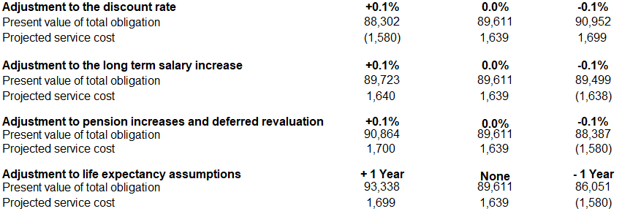
Impact on the Council’s Cash Flows
The objectives of the scheme are to keep employers' contributions at as constant a rate as possible. There are no minimum funding requirements in the LGPS, but the contributions are generally set to target a funding level of 100% using the actuarial valuation assumptions. The employer contribution rate for 2023/24 is 18.5% (2022/23 17.6%). A monetary contribution of £0.84m was paid by the authority in 2023/24. This contribution will reduce over the 3-year period (£0.72m in 2024/25 and £0.6m in 2025/26). The scheme will need to take account of the national changes to the scheme under the Public Pensions Services Act 2013. Under the Act, the Local Government Pension Scheme in England and Wales and the other main existing public service schemes may not provide benefits in relation to service after 31 March 2014 (or service after 31 March 2015 for other main existing public service pension schemes in England and Wales). The Act provides for scheme regulations to be made within a common framework, to establish new career average revalued earnings schemes to pay pensions and other benefits to certain public servants.
The estimated duration of the defined benefit obligation for scheme members is 16 years .

Projected Pension Expense for the Year to 31 March 2025
Note: These projections are based on the assumptions as at 31 March 2024, as described earlier in the Barnett Waddington Actuary Report. The figures exclude the capitalised cost of any early retirements or augmentations which may occur after 31 March 2024.

33. CONTINGENT LIABILITIES
At the 31st of March 2024 the Council had one contingent liability requiring disclosure. The Council gave an environmental warranty as part of the housing stock transfer in 2003, both to Rushcliffe Homes – now Metropolitan Thames Valley Housing Trust and to their lender, Nationwide Building Society. The former ran for 15 years until 2018 and has now elapsed; the latter was for 32 years and will run until 2035. The value of the liability is unknown and to date there have not been any issues identified.

34. CONTINGENT ASSETS
At 31 March 2024 the Council has one contingent assets requiring disclosure:
The Council is party to a collective claim relating to the price fixing of refuse vehicles purchased between 1997 and 2014. A revised estimate of damages suggests the Council’s share of any award is expected to be in the range of £0.523m to £0.777m. These figures are subject to any individual settlement agreements among the six defendant groups, the Litigation Funding Agreement and deduction of funding and legal costs prior to distribution.

35. NATURE AND EXTENT OF RISKS ARISING FROM FINANCIAL INSTRUMENTS
The Council’s activities expose it to a variety of financial risks:
- Credit Risk – the possibility that other parties might fail to pay amounts due to the Council.
- Liquidity Risk – the possibility that the Council might not have funds available to meet its commitments to make payments.
- Market Risk – the possibility that financial loss might arise for the Council as a result of changes in such measures as interest rates and stock market movements.
The Council’s overall risk management programme focuses on the unpredictability of financial markets and seeks to minimise potential adverse effects on the resources available to fund services. Risk management is carried out by a central treasury team, under policies approved by the Council in the Annual Capital and Investment Strategy. The Council provides written principles for overall risk management, as well as written policies covering specific areas, such as interest risk, credit risk and the investment of surplus cash.
Credit Risk
Credit risk arises from deposits with banks and financial institutions, as well as credit exposures to the Council’s customers.
The risk is minimised through the Treasury Management Policy, which requires that deposits are not made with financial institutions unless they meet the identified minimum credit criteria. This means that, ordinarily, the counterparty must have long-term credit ratings of A- or above to reduce the risk of bail-in.
Customers for goods and services are assessed, taking into account their financial position, past experience and other factors, with individual credit limits set in accordance with internal ratings in accordance with parameters set by the Council.
The Council’s maximum exposure to credit risk in relation to its investments in banks and building societies cannot be assessed generally as the risk of any institution failing to make interest payments or repay the principal sum will be specific to each institution. Recent experience has shown that it is rare for such entities to be unable to meet their commitments. There remains a risk that the Council’s deposits could be unrecoverable in the event of an institution failing, but there was no evidence at the 31 March 2024 that this was likely to happen.
No credit limits were exceeded during the reporting period and the Council does not expect any losses from non-performance by any of its counterparties in relation to its deposits.
The Council does not generally allow extended credit for customers, but some of the current balance is past its due date for payment. The past due but not impaired amount can be analysed by age as follows:
**Decrease relates to deferred capital receipt for Sharphill overage
Amounts Arising from Expected Credit Losses
We have assessed the Council’s short- and long-term investments and concluded that the expected credit loss is not material therefore no allowances have been made.
A summary of the Council’s short-term investments are shown below.
Liquidity Risk
The Council has a comprehensive cash flow management system that seeks to ensure that cash is available as needed. If unexpected movements happen, the Council has ready access to borrow from the money markets and the Public Works Loans Board. There is no significant risk that it will be unable to raise finance to meet its commitments under financial instruments. Instead, the risk is that the Council will be bound to replenish a significant proportion of its borrowings at a time of unfavourable interest rates.
The Council sets limits on the proportion of its fixed rate borrowing during specific periods. All trade and other payables are due to be paid in less than one year.
Market Risk
Interest Rate Risk
The Council is exposed to risk in terms of its exposure to interest rate movements on its borrowings and investments. Movement in interest rates have a complex impact on the Council. For instance, a rise in interest rates could have the following effects:
- Borrowings at variable rates – the interest expense charged to the Surplus or Deficit on the Provision of Services would rise.
- Investment at variable rates – interest income credited to the Surplus or Deficit on the Provision of Services will rise.
- Investments at fixed rates – the fair value of the assets will fall.
- Inflation - current high inflation rates heighten the risk of interest rate volatility and in particular the potential for rising interest rates.
Borrowings are not carried at fair value, so nominal gains and losses on fixed rate borrowings would not impact on the Surplus or Deficit on the Provision of Services or Other Comprehensive Income or Expenditure. However, changes in interest payable and receivable on variable rate borrowings and investments will be posted to the Surplus or Deficit on the Provision of Services and affect the General Fund Balance. The Council is cushioned to some degree as it does not have any debt at the Balance Sheet date. Movements in the fair value of fixed rate investments that have a quoted market price will be reflected in Other Comprehensive Income and Expenditure.
As the Council does not have any borrowings at the Balance Sheet date the management of interest rate exposure is focused on its investments. The treasury management team has an active strategy for assessing interest rate exposure that feeds into the setting of the annual budget and which is used to update the budget during the year. This allows any adverse changes to be accommodated.
According to this assessment strategy, at 31 March 2024, if interest rates had been 1% higher or lower with all variables held constant, the effect would be:

Price Risk
The Council’s investment in the CCLA Property Fund, CCLA Diversified Fund, Royal London Enhanced Cash Plus, Ninety-One and Aegon (formerly Kames and Investec) are subject to the risk of falling commercial property prices. However, any movements in price will not impact on the General Fund Balance as regulations are currently in force to remove the impact of the fair value movements on the taxpayer. The Council is using the temporary statutory override agreed by DLUHC (5 years commencing from April 2019 but now extended a further 2 years) to account for any changes in the fair value on its pooled investments.

Foreign Exchange Risk
The Council has no financial assets or liabilities denominated in foreign currencies and therefore has no exposure to loss arising from movements in exchange rates.

36. ACCOUNTING POLICIES
- General Principles
The Statement of Accounts summarises the Council’s transactions for the 2023/24 financial year and its position at the year-end of 31 March 2024. It has been prepared in accordance with the Accounts and Audit Regulations 2015 which require the accounts to be prepared in accordance with proper accounting practices. These practices primarily comprise the Code of Practice on Local Authority Accounting in United Kingdom 2023/24 supported by International Financial Reporting Standards (IFRS) It also complies with guidance notes issued by CIPFA on the application of accounting standards (Standard Statement of Accounting Practice and Financial Reporting Standards) to the local authority accounts.
The accounting convention adopted in the Statement of Accounts is principally historical cost, modified by the revaluation of certain categories of non-current assets and financial instruments.
- Accruals of Income and Expenditure
Activity is accounted for in the year that it takes place, not simply when cash payments are made or received. In particular:
- Revenue from contracts with service recipients, whether for services or the provision of goods, is recognised when (or as) the goods or services are transferred to the service recipient in accordance with the performance obligations in the contract.
- Supplies are recorded as expenditure when they are consumed – where there is a gap between the date supplies are received and their consumption; they are carried as inventories on the Balance Sheet.
- Expenses in relation to services received (including services provided by employees) are recorded as expenditure when the services are received rather than when payments are made.
- Interest payable on borrowings and receivable on investments is accounted for on the basis of the effective interest rate for the relevant financial instrument rather than the cash flows fixed or determined by the contract.
- Where revenue and expenditure have been recognised but cash has not been received or paid, a debtor or creditor for the relevant amount is recorded in the Balance Sheet. Where it is doubtful that debts will be settled, the balance of debtors is written down and a charge made to revenue for the income that might not be collected.

- Cash and Cash Equivalents
Cash is represented by cash in hand and deposits with financial institutions repayable without penalty on notice of not more than 24 hours. Cash equivalents are investments that mature in three months or less from the date of acquisition and that are readily convertible to known amounts of cash with insignificant risk of change in value. In the Cash Flow Statement, cash and cash equivalents are shown net of bank overdrafts that are repayable on demand and form an integral part of the Council’s cash management.
- Prior Period Adjustments, Changes in Accounting Policies and Estimates and Errors
Prior period adjustments may arise as a result of a change in accounting policies or to correct a material error. Changes in accounting estimates are accounted for prospectively, i.e., in the current and future years affected by the change and do not give rise to a prior period adjustment.
Changes in accounting policies are only made when required by proper accounting practices or where the change provides more reliable or relevant information about the effect of transactions, other events and conditions on the Council’s financial position or financial performance.
Where a change is made, it is applied retrospectively (unless stated otherwise) by adjusting opening balances and comparative amounts for the prior period as if the new policy had always been applied.
Material errors discovered in prior period figures are corrected retrospectively by amending opening balances and comparative amounts for the prior period.
- Charges to Revenue for Non-Current Assets
Services, support services and trading accounts are debited with the following amounts to record the cost of holding fixed assets during the year:
- Depreciation attributable to the assets used by the relevant service;
- Revaluation and impairment losses on assets used by the service where there are no accumulated gains in the Revaluation Reserve against which the losses can be written off; and
- Amortisation of intangible fixed assets attributable to the service.
The Council is not required to raise Council Tax to cover depreciation, revaluation and impairment losses or amortisation. It is however, required to make annual provision from revenue towards the reduction in its overall borrowing requirement; this is referred to as Minimum Revenue Provision (MRP). Guidance was issued by the Secretary of State under section 21 (1A) of the Local Government Act 2003 for the calculation of this provision updated 10 April 2024.
Depreciation, revaluation and impairment losses and amortisation are therefore replaced by the MRP contribution in the general fund balance by way of an adjusting transaction with the capital adjustment account in Movement in Reserves Statement (MIRS) for the difference between the two.

- Employee Benefits
Benefits payable during employment
Short-term employee benefits are those due to be settled within 12 months of the year-end. They include such benefits as wages and salaries, paid annual leave and paid sick leave for current employees and are recognised as an expense for services in the year in which employees render service to the Council. Where material an accrual is made for the cost of holiday entitlements (or any form of leave, for example, time off in lieu) earned by employees but not taken before the year-end which employees can carry forward into the next financial year. The accrual is made at the wage and salary rates applicable in the following year, being the period in which the employee takes the benefit. The accrual is charged to Surplus or Deficit on the Provision of Services, but then reversed out through the MIRS so that holiday benefits are charged to revenue in the financial year in which the holiday absence occurs.
Termination Benefits
Termination benefits are amounts payable as a result of a decision by the Council to either terminate an officer’s employment before the normal retirement date or an officer’s decision to accept voluntary redundancy. These are charged on an accruals basis to the appropriate service segment or, where applicable to a corporate service segment at the earlier of when the Council can no longer withdraw the offer of those benefits or when the Council recognises costs for a restructuring.
When termination benefits involve the enhancement of pensions, statutory provisions require the General Fund balance to be charged with the amount payable by the Council to the pension fund or pensioner in the year, not the amount calculated according to the relevant accounting standards. In the MIRS, appropriations are required to and from the Pension Reserve to remove the notional debits and credits for pension enhancement termination benefits. These are replaced with debits for the cash paid to the pension fund and pensioners and any such amounts payable but unpaid at the year-end.
Post-Employment Benefits
Employees are members of the Local Government Pension Scheme (LGPS), which is administered by Nottinghamshire County Council and is accounted for as a defined benefits scheme providing defined benefits to members (Retirement Lump Sums and Pensions) earned as employees working for the Council.
The liabilities of the pension scheme attributable to the Council are included in the Balance Sheet on an actuarial basis using the projected unit credit method – (i.e., an assessment of the future payments that will be made in relation to retirement benefits earned to date by employees, based on assumptions about mortality rates, employee turnover rates, etc., and projected earnings for current employees).
Liabilities are discounted to their value at current prices, using a discount rate set to market conditions (using the annualised Merrill Lynch AA rated corporate bond yield curve). The assets of the pension fund attributed to the Council are included in the Balance Sheet at their fair value
- Quoted Securities - current bid price
- Unquoted Securities – professional estimate
- Unitised Securities - current bid price
- Property - market value
The change in the net pension’s liability is analysed into five components:
  - Service costs comprising:
    - Current Service Cost – the increase in liabilities as a result of years of service earned this year – allocated in the Comprehensive Income and Expenditure Statement to the service for which the employees worked.
    - Past Service Cost – the increase in liabilities arising from current year decisions whose effect relates to years of service earned in earlier years – debited to the Surplus or Deficit on the Provision of Services in the Comprehensive Income and Expenditure Statement as part of Non-Distributed Costs.
    - Net interest on the net defined benefit liability (asset) i.e. net interest expense for the Council– the change during the period in the net defined benefit liability (asset) that arises from the passage of time charged to the Financing and Investment Income and Expenditure line of the Comprehensive Income and Expenditure Statement – this is calculated by applying the discount rate used to measure the defined benefit obligation at the beginning of the period to the net defined benefit liability (asset) at the beginning of the period – taking into account any changes in the net defined benefit liability (asset) during the period as a result of contribution and benefit payments.
  - Re-measurements comprising
    - The return on plan assets – excluding amounts included in net interest on the net defined benefit liability (asset) – charged to the Pension Reserve as Other Comprehensive Income and Expenditure;
    - Actuarial gains and losses – changes in the net pensions liability that arise because events have not coincided with assumptions made at the last actuarial valuation or because the actuaries have updated their assumptions– charged to the Pensions Reserve as Other Comprehensive Income and Expenditure.
  - Contributions Paid to the Pension Fund – cash paid as employer’s contributions to the pension fund in settlement of liabilities; not accounted for as an expense.

In relation to retirement benefits, statutory provisions require the General Fund balance to be charged with the amount payable by the Council to the pension fund, or directly to pensioners in the year, not the amount calculated according to the relevant accounting standards. In the MIRS, this means that there are appropriations to and from the Pensions Reserve to remove the notional debits and credits for retirement benefits and replace them with debits for the cash paid to the pension fund and pensioners, and any amounts payable to the fund but unpaid at the year-end. The negative balance that arises on the Pensions Reserve thereby measures the beneficial impact to the General Fund of being required to account for retirement benefits on the basis of cash flows rather than as benefits are earned by employees.
Discretionary Benefits
The Council has restricted powers to make discretionary awards of retirement benefits in the event of early retirements. Any liabilities estimated to arise as a result of an award to any member of staff are accrued in the year of the decision to make the award and accounted for using the same policies as are applied to the LGPS.

- Events after the Balance Sheet Date
Events after the Balance Sheet date are those events, both favourable and unfavourable, that occur between the end of the reporting period and the date when the Statement of Accounts is authorised for issue. Two types of events can occur:
- Those that provide evidence of conditions that existed at the end of the reporting period – the Statement of Accounts is adjusted to reflect such events;
- Those that are indicative of conditions that arose after the reporting period – the Statement of Accounts are not adjusted to reflect such events, but where a category of events would have a material effect, disclosure is made in the notes of the nature of the events and their estimated financial effect.
Events taking place after the date of authorisation for issue are not reflected in the Statement of Accounts.

- Financial Instruments
General
The Council recognises a financial asset or liability on the Balance Sheet when it becomes party to the contractual provisions of an instrument.
Financial Liabilities
Financial liabilities are recognised on the balance sheet when the Council becomes a party to the contractual provisions of a financial instrument and are initially measured at fair value and carried at their amortised cost. Annual charges to the Financing and Investment Income and Expenditure line in the Comprehensive Income and Expenditure Statement for interest payable, are based on the carrying amount of liability, multiplied by the effective rate of interest for the instrument. The effective interest rate is the rate that exactly discounts estimated future cash payments over the life of the instrument to the amount at which it was originally recognised.
The Council currently has no long-term debt, but any future long-term debt would be within the Council’s Treasury Management Strategy, Minimum Revenue Provision Policy and future Accounting Policies.
Financial Assets
Financial assets are classified based on a classification and measurement approach that reflects the business model for holding the financial assets and their cashflow characteristics. There are three main classes of financial assets measured at:

- amortised cost
- fair value through profit or loss (FVPL), and
- fair value through other comprehensive income (FVOCI)

The Council’s business model is to hold investments to collect contractual cash flows. Financial assets are therefore classified as amortised cost, except for those whose contractual payments are not solely payment of principal and interest.
Financial Assets Measured at Amortised Cost
Financial assets measured at amortised cost are recognised on the Balance Sheet when the Council becomes a party to the contractual provisions of a financial instrument and are initially measured at fair value. They are subsequently measured at their amortised cost. Annual credits to the Financing and Investment Income and Expenditure line in the Comprehensive Income and Expenditure Statement (CIES) for interest receivable are based on the carrying amount of the asset multiplied by the effective rate of interest for the instrument. For most of the financial assets held by the authority, this means that the amount presented in the Balance Sheet is the outstanding principal receivable (plus accrued interest) and interest credited to the CIES is the amount receivable for the year in the loan agreement.
In the event that the Council makes a loan to an outside body at less than market rates (soft loans) and the present value of the interest foregone is greater than £50k, a loss is recorded in the CIES (debited to the appropriate service) for the present value of the interest that will be foregone over the life of the instrument, resulting in a lower amortised cost than the outstanding principal.
Interest is credited to the Financing and Investment Income and Expenditure line in the CIES at a marginally higher effective rate of interest than the rate receivable from the voluntary organisations, with the difference serving to increase the amortised cost of the loan in the Balance Sheet. Statutory provisions require that the impact of soft loans on the General Fund Balance is the interest receivable for the financial year – the reconciliation of amounts debited and credited to the CIES to the net gain required against the General Fund Balance is managed by a transfer to or from the Financial Instruments Adjustment Account in the MIRS.
Any gains and losses that arise on the derecognition of an asset are credited or debited to the Financing and Investment Income and Expenditure line in the CIES.
Expected Credit Loss Model
The authority recognises expected credit losses on all of its financial assets held at amortised cost [or where relevant FVOCI], either on a 12-month or lifetime basis. The expected credit loss model also applies to lease receivables and contract assets. Only lifetime losses are recognised for trade receivables (debtors) held by the authority.
Impairment losses are calculated to reflect the expectation that the future cash flows might not take place because the borrower could default on their obligations. Credit risk plays a crucial part in assessing losses. Where risk has increased significantly since an instrument was initially recognised, losses are assessed on a lifetime basis. Where risk has not increased significantly or remains low, losses are assessed on the basis of 12-month expected losses.
The current cost of living pressures have been considered when assessing potential impairment of debt.
Financial Assets measured at Fair Value through Other Comprehensive Income
Financial assets measured at fair value through other comprehensive income are recognised on the balance sheet when the authority becomes a party to the contractual provisions of a financial instrument and are initially measured and carried at fair value. Annual income received from the financial instrument is credited to the Financing and Investment Income and Expenditure line in the Comprehensive Income and Expenditure Statement when it becomes receivable by the authority.
Financial Assets Measured at Fair Value through Profit and Loss
Financial assets that are measured at FVPL are recognised on the Balance Sheet when the authority becomes a party to the contractual provisions of a financial instrument and are initially measured and carried at fair value. Fair value gains and losses are recognised as they occur in the Surplus or Deficit on the Provision of Services.
Fair Value measurement of Financial Assets
Fair value of an asset is the price that would be received to sell an asset in an orderly transaction between market participants at the measurement date. The fair value measurements of the authority’s financial assets are based on the following techniques:
- instruments with quoted market prices – the market price
- other instruments with fixed and determinable payments – discounted cash flow analysis.

The inputs to the measurement techniques are categorised in accordance with the following three levels:
- Level 1 inputs – quoted prices (unadjusted) in active markets for identical assets that the authority can access at the measurement date.
- Level 2 inputs – inputs other than quoted prices included within Level 1 that are observable for the asset, either directly or indirectly.
Level 3 inputs – unobservable inputs for the asset.
Any gains and losses that arise on the derecognition of the asset are credited or debited to the Financing and Investment Income and Expenditure line in the Comprehensive Income and Expenditure Statement.
The Council holds shares in CCLA Property fund, CCLA Better World Fund (Formerly Diversified Fund), Royal London Enhanced Cash Plus Fund, Aegon and Ninety-One (formerly Kames and Investec). Any movement in Fair Value will be accounted for in Financing and Investment Income and Expenditure line in Surplus/Deficit on Provision of Services. A statutory override must be used to reverse the entry in the CIES to a reserve to recognise the fair value gains and losses.
- Government Grants and Contributions
Whether paid on account, by instalments or in arrears, government grants, third party contributions and donations are recognised as due to the Council where there is reasonable assurance that.
- The Council will comply with the conditions attached to the payments; and
- The grants or contributions will be received.

Amounts recognised as due to the Council are not credited to the Comprehensive Income and Expenditure Statement until conditions attached to the grant or contribution have been satisfied. Conditions are stipulations that specify that the future economic benefits or service potential embodied in the asset acquired using the grant or contribution are required to be consumed by the recipient as specified, or future economic benefits or service potential must be returned to the transferor.
Monies advanced as grants and contributions for which conditions have not been satisfied are carried in the Balance Sheet as creditors (Receipts in Advance). When conditions are satisfied, the grant or contribution is credited to the Comprehensive Income and Expenditure Statement.
Where capital grants and contributions including Section 106s awarded to Rushcliffe Borough Council are credited to the Comprehensive Income Expenditure Statement as Taxation and Non-Specific Grant Income, they are reversed out of the General Fund Balance in the MIRS. Where the grant has yet to be used to finance capital expenditure it is posted to the Capital Grants Unapplied Reserve. Where it has been applied, it is posted to the Capital Adjustment Account. Amounts in the Capital Grants Unapplied Reserve are transferred to the Capital Adjustment Account once they have been applied to fund capital expenditure.
Community Infrastructure Levy
The Council has elected to charge a Community Infrastructure Levy (CIL). The levy is charged on new builds (chargeable developments for the authority) with appropriate planning consent. The Council charges for and collects the levy, which is a planning charge. The income from the levy will be used to fund a number of infrastructure projects to support the development of the area. The charge came into force on 7th October 2019.
CIL is received without outstanding conditions; it is therefore recognised at the commencement date of the chargeable development in the Comprehensive Income and Expenditure Statement in accordance with the accounting policy for government grants and contributions set out above. CIL charges will be largely used to fund capital expenditure. However, a proportion of the charges may be used to fund revenue expenditure.
- Heritage Assets
The Council has Heritage Assets; a small art collection; war memorabilia (war memorial and commemorative bench); and Covid Memorial Obelisk. Heritage Assets are carried at valuation rather than current of fair value reflecting the fact that sales and exchanges are uncommon. The Art Collection is valued at insurance valuation and the War Memorial, bench and Obelisk at depreciated historic cost as they are infrastructure assets. The treatment of revaluation gains and losses is in accordance with the Council’s accounting policies on property, plant and equipment.
The carrying amounts of Heritage Assets are reviewed where there is evidence of impairment, for example, where an item has suffered physical deterioration or breakage or where doubts arise as to its authenticity. Any impairment is recognised and measured in accordance with the Council’s general policies on impairment.

Art collection
The assets within the art collection are deemed to have indeterminate lives; hence the Council does not consider it appropriate to charge depreciation.
Acquisitions are made by purchase or donation. Purchases are initially recognised at cost and donations are recognised at valuation.

War Memorial and Bench and Covid Memorial Obelisk
The War Memorial, Commemorative Bench and Obelisk are sited in West Bridgford and held at Depreciated Historical Cost (a proxy for current value).

- Intangible Assets
Expenditure on non-monetary assets that do not have physical substance but are controlled by the Council as a result of past events (for example, software licences). These are capitalised when it is expected that future economic benefits or service potential will flow from the intangible asset to the Council.
Internally generated assets are capitalised where it is demonstrable that the project is technically feasible and is intended to be completed (with adequate resources being available) and the authority will be able to generate future economic benefits or deliver service potential by being able to sell or use the asset. Expenditure is capitalised where it can be measured reliably as attributable to the asset and is restricted to that incurred during the development phase (research expenditure cannot be capitalised).
Intangible assets are measured initially at cost. Amounts are only revalued where the fair value of the assets held by the authority can be determined by reference to an active market. In practice, no intangible asset held by the authority meets this criterion, and they are therefore carried at amortised cost. The depreciable amount of an intangible asset is amortised over its useful life to the relevant service line(s) in the Comprehensive Income and Expenditure Statement. An asset is tested for impairment whenever there is an indication that the asset might be impaired – any losses recognised are posted to the relevant service line(s) in the Comprehensive Income and Expenditure Statement. Any gain or loss arising on the disposal or abandonment of an intangible asset is posted to the Other Operating Expenditure line in the Comprehensive Income and Expenditure Statement.
Where expenditure on intangible assets qualifies as capital expenditure for statutory purposes, amortisation, impairment losses and disposal gains and losses are not permitted to have an impact on the General Fund Balance. The gains and losses are therefore reversed out of the General Fund Balance in the MIRS and posted to the Capital Adjustment Account and (for any sale proceeds greater than £10,000) the Capital Receipts Reserve.
- Inventories and Long-Term Contracts
Inventories are included in the Balance Sheet at the lower of cost and net realisable value. Long term contracts are accounted for on the basis of charging the surplus or deficit on the provision of services with the consideration allocated to the performance obligations satisfied based on goods or services transferred to the service recipient during the financial year.
- Interests in Companies and Other Entities
The Council does not have material interests in companies and other entities that have the nature of subsidiaries, associates and jointly controlled entities and require it to prepare group accounts.
- Investment Property
Investment properties are those that are used solely to earn rentals and/or for capital appreciation. The definition is not met if the property is used in any way to facilitate the delivery of services or production of goods or is held for sale.
Investment properties are measured initially at cost and subsequently at fair value and are not depreciated but are re-valued annually. Gains and losses on revaluation are posted to the Financing and Investment Income and Expenditure line in the Comprehensive Income and Expenditure Statement. The same treatment is applied to gains and losses on disposal.
Rentals received in relation to investment properties are credited to the Financing and Investment Income line and result in a gain for the General Fund Balance. However, revaluation and disposal gains and losses are not permitted by statutory arrangements to have an impact on the General Fund Balance. The gains and losses are therefore reversed out of the General Fund Balance in the MIRS and posted to the Capital Adjustment Account and the Capital Receipts Reserve (for any sale proceeds greater than £10,000).
- Leases
Leases are classified as finance leases where the terms of the lease transfer substantially all the risks and rewards incidental to ownership of the property, plant or equipment from the lessor to the lessee. All other leases are classified as operating leases.
An exception is made where leases were in existence prior to the introduction of IFRS 16 and not treated in accordance with proper practice as at 31st March 2010. Under the terms of the Local Authorities (Capital Finance and Accounting) (Amendment) (England) Regulations 2010 no 454, the Council may continue to account for money received in accordance with the original type of leases.
Leases classified as Investment Properties are not required to show a split between the land and building elements.
Where a lease covers both land and buildings, the land and buildings elements are considered separately for classification.
Arrangements that do not have the legal status of a lease but convey a right to use an asset in return for payment are accounted for under this policy where fulfilment of the arrangement is dependent on the use of a specific asset.
The Council as Lessee
Finance Leases
Property, plant and equipment held under finance leases is recognised on the Balance Sheet at the commencement of the lease at its fair value measured at the lease’s inception (or the present value of the minimum lease payments, if lower). The asset recognised is matched by a liability for the obligation to pay the lessor. Initial direct costs of the Council are added to the carrying amount of the asset. Premiums paid on entry into a lease are applied to writing down the lease liability. Contingent rents are charged as expenses in the periods in which they are incurred.
Lease payments are apportioned between:
- A charge for the acquisition of the interest in the property, plant or equipment – applied to write down the lease liability, and
- A finance charge (debited to the Financing and Investment Income and Expenditure line in the Comprehensive Income and Expenditure Statement).
Property, plant and equipment recognised under finance leases is accounted for using the policies applied generally to such assets, subject to depreciation being charged over the lease term if this is shorter than the asset’s estimated useful life (where ownership of the asset does not transfer to the Council at the end of the lease period).
The Council is not required to raise council tax to cover depreciation or revaluation and impairment losses arising on leased assets. Instead, a prudent annual contribution is made from revenue funds towards the deemed capital investment in accordance with statutory requirements. Depreciation and revaluation and impairment losses are therefore substituted by a revenue contribution in the General Fund Balance, by way of an adjusting transaction with the Capital Adjustment Account in the MIRS for the difference between the two.
Operating Leases
Rentals paid under operating leases are charged to the Comprehensive Income and Expenditure Statement as an expense of the services benefiting from the leased asset.
Charges are made on a straight-line basis over the life of the lease, even if this does not match the pattern of payments (e.g., there is a rent-free period at the commencement of the lease).
The Council as Lessor
Finance Leases
Where the authority grants a finance lease over a property or an item of plant or equipment, the relevant asset is written out of the Balance Sheet as a disposal. At the commencement of the lease, the carrying amount of the asset in the Balance Sheet (whether property, plant and equipment or assets held for sale) is written off to the Other Operating Expenditure line in the Comprehensive Income and Expenditure Statement as part of the gain or loss on disposal. A gain, representing the authority’s net investment in the lease, is credited to the same line in the Comprehensive Income and Expenditure Statement also as part of the gain or loss on disposal (i.e., netted off against the carrying value of the asset at the time of disposal), matched by a lease (long-term debtor) asset in the Balance Sheet.
Lease rentals receivable are apportioned between: a charge for the acquisition of the interest in the property – applied to write down the lease debtor (together with any premiums received), and finance income (credited to the Financing and Investment Income and Expenditure line in the Comprehensive Income and Expenditure Statement).
The gain credited to the Comprehensive Income and Expenditure Statement on disposal is not permitted by statute to increase the General Fund Balance and is required to be treated as a capital receipt. Where a premium has been received, this is posted out of the General Fund Balance to the Capital Receipts Reserve in the MIRS. Where the amount due in relation to the lease asset is to be settled by the payment of rentals in future financial years, this is posted out of the General Fund Balance to the Deferred Capital Receipts Reserve (England and Wales) in the MIRS. When the future rentals are received, the element for the capital receipt for the disposal of the asset is used to write down the lease debtor. At this point, the deferred capital receipts are transferred to the Capital Receipts Reserve (England and Wales).
The written-off value of disposals is not a charge against council tax, as the cost of non-current assets is fully provided for under separate arrangements for capital financing. Amounts are therefore appropriated to the Capital Adjustment Account from the General Fund Balance in the MIRS.
Operating Leases
Where the authority grants an operating lease over a property or an item of plant or equipment, the asset is retained in the Balance Sheet. Rental income is credited to the Other Operating Expenditure line in the Comprehensive Income and Expenditure Statement. Credits are made on a straight-line basis over the life of the lease, even if this does not match the pattern of payments (e.g., there is a premium paid at the commencement of the lease). Initial direct costs incurred in negotiating and arranging the lease are added to the carrying amount of the relevant asset and charged as an expense over the lease term on the same basis as rental income.

The authority does not have any sale and leaseback assets.
- Jointly Controlled Operations
Jointly controlled operations are activities undertaken by the Council in conjunction with other joint operators that involve the use of assets and resources of the venture rather than the establishment of a separate entity. The Council recognises on its Balance Sheet the assets that it controls and the liabilities that it incurs and debits and credits the Comprehensive Income and Expenditure Statement with the expenditure it incurs and the share of income it earns from the activity of the operation.
- Overheads and Support Services
The costs of overheads and support services are charged to service areas in accordance with the Council’s arrangements for accountability and financial performance.
- Property, Plant & Equipment
Assets that have physical substance and are held for use in the production or supply of goods or services, for rental to others, or for administrative purposes and that are expected to be used during more than one financial year are classified as Property, Plant and Equipment.
Recognition
Expenditure on the acquisition, creation or enhancement of Property, Plant and Equipment is capitalised on an accruals basis, provided that it is probable that the future economic service potential associated with the item will flow to the Council and the cost of the item can be measured reliably. Expenditure that maintains but does not add to an asset’s potential to deliver future economic benefits or service potential is charged as an expense when it is incurred. In addition, expenditure needs to be in excess of the Council de-minimis level of £10,000 before it can be recognised as capital, spend below this limit is charged to revenue.
The Code requires components to be accounted for as separate items where they are material, the Council has undertaken a review of its assets relating to Property, Plant and Equipment and componentising these assets has no material impact. The Council has however componentised its assets, into two elements, land and buildings.

Measurement
Assets are initially measured at cost, comprising:
- The purchase price
- Any costs attributable to bringing the asset to the location and condition necessary for it to be capable of operating in the manner intended by management
- The initial estimate of the costs of dismantling and removing the item and restoring the site on which it is located.
The cost of assets acquired other than by purchase is deemed to be its fair value, unless the acquisition does not have commercial substance, (i.e., it will not lead to variation in the cash flows of the Council). In the latter case, where an asset is acquired via exchange, the cost of the acquisition is the carrying amount of the asset given up by the council.
Donated assets are measured initially at fair value unless the donation has been made conditionally. The difference between fair value and any consideration paid is credited to the Taxation and Non-Specific Grant Income line of the Comprehensive Income and Expenditure Statement. Until conditions are satisfied, the gain is held in the Donated Assets Account. Where gains are credited to the Comprehensive Income and Expenditure Statement, they are reversed out of the General Fund Balance to the Capital Adjustment Account in the MIRS.

Assets are then carried in the Balance Sheet using the following measurement bases:
Property, Plant and Equipment  Other Land and Buildings  Vehicles and Plant  Infrastructure  Community Assets  Assets Under Construction | Existing Use Value (EUV)  Depreciated Historical Cost  Depreciated Historical Cost  Depreciated Historical Cost  Depreciated Historical Cost
Assets included in the Balance Sheet at fair value are re-valued sufficiently regularly to ensure that their carrying amount is not materially different from their fair value at the year-end, but as a minimum every three years. Increases in valuations are matched by credits to the Revaluation Reserve to recognise unrealised gains. Exceptionally, gains might be credited to the Surplus and Deficit on the Provision of Services line of the Comprehensive Income and Expenditure Statement where they arise from the reversal of a loss previously charged to a service.
Where decreases in value are identified, they are accounted for as follows:
- Where there is a balance of revaluation gains for the asset in the Revaluation Reserve, the carrying amount of the asset is written down against that balance (up to the amount of the accumulated gains)
- Where there is no balance in the Revaluation Reserve or an insufficient balance, the carrying amount of the asset is written down against the relevant service line(s) in the Comprehensive Income and Expenditure Statement.
The Revaluation Reserve contains revaluation gains recognised since 1 April 2007 only, the date of its formal implementation. Gains arising before that date have been consolidated into the Capital Adjustment Account.

Impairment
Assets are assessed at each year-end as to whether there is any indication that an asset may be impaired. Where indications exist and any possible differences are estimated to be material, the recoverable amount of the asset is estimated and, where this is less than the carrying amount of the asset, an impairment loss is recognised for the shortfall.

Where impairment losses are identified, they are accounted for by:
- Where there is a balance of revaluation gains for the asset in the Revaluation Reserve, the carrying amount of the asset is written down against that balance (up to the amount of the accumulated gains)
- Where there is no balance in the Revaluation Reserve or an insufficient balance, the carrying amount of the asset is written down against the relevant service line(s) in the Comprehensive Income and Expenditure Statement.
Where an impairment loss is reversed subsequently, the reversal is credited to the relevant service line(s) in the Comprehensive Income and Expenditure Statement, up to the amount of the original loss, adjusted for depreciation that would have been charged if the loss had not been recognised.

Depreciation
Depreciation is provided for on all Property, Plant and Equipment assets by the systematic allocation of their depreciable amounts over their useful lives. An exception is made for assets without a determinable finite useful life (i.e., freehold land and certain Community Assets) and assets that are not yet available for use (i.e., assets under construction) and assets held for a commercial return (i.e., investment properties). It is calculated as follows:
Property, Plant and Equipment  Other Land and Buildings  Vehicles and Plant  Infrastructure | Straight line – over the useful life of the asset  Straight line – over the useful life of the asset  Straight line – over the useful life of the asset
Revaluation gains are also depreciated, with an amount equal to the difference between current value depreciation charged on assets and the depreciation that would have been chargeable based on their historical cost being transferred each year from the Revaluation Reserve to the Capital Adjustment Account.

Infrastructure Assets within PPE
Infrastructure assets are generally inalienable assets, expenditure on which is only recoverable by continued use of the asset created, i.e., there is no prospect of sale or alternative use. They work as a part of a continuous network that is maintained in a relatively steady state, though there may be distinctive parts of this network. For Rushcliffe, the steady state will be play area ground infrastructure, and footpath enhancements; a distinctive part and significant infrastructure asset is Cotgrave Public Realm.

Recognition
Expenditure on the acquisition/development of Infrastructure assets is capitalised on an historic cost (accruals) basis, provided that the future economic benefits associated with the item will flow to the authority and the cost of the item can be measured reliably.
Measurement
Infrastructure assets are measured at depreciated historic cost.
Depreciation
Depreciation is calculated on a straight-line basis over the assigned useful life of the asset. Useful lives for Infrastructure assets are assessed by the relevant Commissioning Officer.
Disposal and De-recognition of Infrastructure Assets
When an infrastructure asset is disposed/replaced/de-commissioned, the carrying amount of the asset is written off to the ‘Other operating expenditure’ line in the Comprehensive Income and Expenditure Statement. The expectation is that the replacement parts will have been fully depreciated but this may not always be the case.
The written-off amounts of disposals are not a charge against Council Tax, as the cost of non-current assets is fully provided for under separate capital financing accounting arrangements. Amounts are transferred to the Capital Adjustment Account from the General Fund via the MIRS.
Disposals and Non-current Assets Held for Sale
When it becomes probable that the carrying amount of an asset will be recovered principally through a sale transaction rather than through its continuing use, it is reclassified as an Asset Held for Sale. The asset is re-valued immediately before reclassification and then carried at the lower of this amount and fair value less costs to sell. Where there is a subsequent decrease to fair value less costs to sell, the loss is posted to the Other Operating Expenditure line in the Comprehensive Income and Expenditure Statement. Gains in fair value are recognised only up to the amount of any previous losses recognised in the Surplus or Deficit on Provision of Services. Depreciation is not charged on Assets Held for Sale.
If assets no longer meet the criteria to be classified as Assets Held for Sale, they are reclassified back to non-current assets and valued at the lower of their carrying amount before they were classified as held for sale; adjusted for depreciation, amortisation or revaluations that would have been recognised had they not been classified as Held for Sale, and their recoverable amount at the date of the decision not to sell. Assets that are to be abandoned or scrapped are not reclassified as Assets Held for Sale.
When an asset is disposed of or decommissioned, the carrying amount of the asset in the Balance Sheet (whether Property, Plant and Equipment or Assets Held for Sale) is written off to the Other Operating Expenditure line in the Comprehensive Income and Expenditure Statement as part of the gain or loss on disposal. Receipts from disposals (if any) are credited to the same line in the Comprehensive Income and Expenditure Statement also as part of the gain or loss on disposal (i.e., netted off against the carrying value of the asset at the time of disposal). Any revaluation gains accumulated for the asset in the Revaluation Reserve are transferred to the Capital Adjustment Account. Amounts received for a disposal in excess of £10,000 are categorised as capital receipts. Capital receipts are credited to the Capital Receipts Reserve and can then only be used for new capital investment or set aside to reduce the authority’s underlying need to borrow (the capital financing requirement). Receipts are appropriated to the Reserve from the General Fund Balance in the MIRS.
As the cost of fixed assets is fully provided for under separate arrangements for capital finance the written-off value of disposals is not a charge against council tax. Amounts are appropriated to the Capital Adjustment Account from the General Fund Balance in the MIRS.
Assets under Construction
Assets under Construction are only recognised when it is probable that the future economic benefits will flow to the Council and the cost can be measured reliably. Assets under construction are capitalised at cost which includes labour and overhead costs arising directly from the construction of the asset. Assets under construction are not depreciated until they are brought into use under the relevant sections of Property Plant and Equipment.
- Provisions, Contingent Liabilities and Contingent Assets
Provisions
Provisions are made where an event has taken place that gives the Council a legal or constructive obligation that probably requires settlement by a transfer of economic benefits or service potential, and a reliable estimate can be made of the amount of the obligation. For instance, the Council may be involved in a court case that could eventually result in the making of a settlement or the payment of compensation.
Provisions are charged as an expense to the appropriate service line in the Comprehensive Income and Expenditure Statement in the year that the Council becomes aware of the obligation and are measured at the best estimate at the balance sheet date of the expenditure required to settle the obligation, taking into account relevant risks and uncertainties.
When payments are eventually made, they are charged to the provision carried in the Balance Sheet. Estimated settlements are reviewed at the end of each financial year – where it becomes less than probable that a transfer of economic benefits will now be required (or a lower settlement than anticipated is made), the provision is reversed and credited back to the relevant service.
Where some or all of the payment required to settle a provision is expected to be recovered from another party (e.g., from an insurance claim), this is only recognised as income for the relevant service if it is virtually certain that reimbursement will be received if the Council settles the obligation.
Contingent Liabilities
A contingent liability arises where an event has taken place that gives the Council a possible obligation whose existence will only be confirmed by the occurrence or otherwise of uncertain future events not wholly within the control of the Council. Contingent liabilities also arise in circumstances where a provision would otherwise be made but either it is not probable that an outflow of resources will be required, or the amount of the obligation cannot be measured reliably. Contingent liabilities are not recognised in the Balance Sheet but disclosed in a note to the accounts.
Contingent Assets
A contingent asset arises where an event has taken place that gives the Council a possible asset whose existence will only be confirmed by the occurrence or otherwise of uncertain future events not wholly within the control of the Council. Where it is probable that there will be an inflow of economic benefits or service potential, contingent assets are not recognised in the Balance Sheet but disclosed in a note to the Accounts.

- Reserves
The Council sets aside specific amounts as reserves for future policy purposes or to cover contingencies. Reserves are created by appropriating amounts out of the General Fund Balance in the MIRS. When expenditure to be financed from a reserve is incurred, it is charged to the appropriate service in that year to score against the Surplus or Deficit on the Provision of Services in the Comprehensive Income and Expenditure Statement. The reserve is then appropriated back into the General Fund Balance in the MIRS so that there is no net charge against council tax for the expenditure.
Certain reserves are kept to manage the accounting processes for non-current assets, financial instruments, and retirement and employee benefits and do not represent usable resources for the Council – these reserves are explained in the relevant policies.
- Revenue Expenditure Funded from Capital under Statute
Expenditure incurred during the year that may be capitalised under statutory provisions but does not result in the creation of a non-current asset has been charged as expenditure to the relevant service in the Comprehensive Income and Expenditure Statement in the year. Where the Council has determined to meet the cost of this expenditure from existing capital resources or by borrowing, a transfer in the MIRS from the General Fund Balance to the Capital Adjustment Account then reverses out the amounts charged so that there is no impact on the level of council tax.
- VAT
VAT payable is included only where it is deemed unrecoverable from His Majesty’s Revenue and Customs. VAT receivable is excluded from income.
Non-recoverable VAT relating to a capital scheme will form part of the capital cost of that scheme
- Collection Fund – Council Tax & Non-Domestic Rates (NDR)
Billing authorities are required by statute to maintain a separate fund for the collection and distribution of amounts due in respect of council tax and business rates. The Council acts as an agent, collecting and distributing council tax and business rates income on behalf the major precepting authorities and central government, and as a principle, collecting council tax and NDR for itself.
The council tax and NDR income included in the Comprehensive Income and Expenditure Statement is the authority’s share of accrued income for the year. Any difference between the income included in the CIES and the demand or precept is taken to the Collection Fund Adjustment Account and included as a reconciling item in the MIRS . The Balance Sheet includes the authority’s share of the end of year balances in respect of council tax and NDR relating to arrears, impairment allowances for doubtful debts, overpayments and prepayments and appeals. As the collection of Council Tax and NDR is an agency agreement there is a debtor/creditor position between the Council, the major preceptors and central government. As the billing authority, this Council’s Cash Flow Statement includes in ‘revenue activities’ only its own share of the Council Tax and NDR collected.

- Fair Value Measurement of non-financial assets

The Council measures some of its non-financial assets such as surplus assets and investment properties and some of its financial instruments at fair value at each reporting date. Fair value is the price that would be received to sell an asset or paid to transfer a liability in an orderly transaction between market participants at the measurement date. The fair value measurement assumes that the transaction to sell the asset or transfer the liability takes place either:
a) in the principal market for the asset or liability, or
b) in the absence of a principal market, in the most advantageous market for the asset or liability.
The Council measures the fair value of an asset or liability using the assumptions that market participants would use when pricing the asset or liability, assuming that market participants act in their economic best interest.
When measuring the fair value of a non-financial asset, the Council takes into account a market participant’s ability to generate economic benefits by using the asset in its highest and best use or by selling it to another market participant that would use the asset in its highest and best use.
The Council uses valuation techniques that are appropriate in the circumstances and for which sufficient data is available, maximising the use of relevant observable inputs and minimising the use of unobservable inputs. The hierarchy below is used.
- Level 1 – quoted prices (unadjusted) in active markets for identical assets or liabilities that the authority can access at the measurement date
          - Level 2 – inputs other than quoted prices included within Level 1 that are observable for the asset or liability, either directly or indirectly
- Level 3 – unobservable inputs for the asset or liability.

37. ACCOUNTING STANDARDS ISSUED BUT HAVE NOT YET BEEN ADOPTED
The Code of Practice on Local Authority Accounting in the United Kingdom 2023/24 (the Code) requires the disclosure of information relating to the expected impact on the accounting change that will be required by a new standard that has been issued but not yet adopted by the Code for the relevant financial year. This applies to the adoption of the following new or amended standards within the 2023/24 code:
The standards introduced by the 2024/25 Code where disclosures are required in the 2023/24
financial statements, in accordance with the requirements of paragraph 3.3.4.3 of the Code, are:
- IFRS 16 Leases issued in January 2016 (but only for those local authorities that have not decided to voluntarily implement IFRS 16 in the 2023/24 year)
- Classification of Liabilities as Current or Non-current (Amendments to IAS 1)
- Lease Liability in a Sale and Leaseback (Amendments to IFRS 16)
- Non-current Liabilities with Covenants (Amendments to IAS 1)
- International Tax Reform: Pillar Two Model Rules (Amendments to IAS 12)
- Supplier Finance Arrangements (Amendments to IAS 7 and IFRS 7)

38. CRITICAL JUDGEMENTS IN APPLYING ACCOUNTING POLICIES
In applying the accounting policies set out in Note 36 the Council has had to make certain judgements about complex transactions or those involving uncertainty about future events. The critical judgements made in the Statement of Accounts concern the following:
- There is a high degree of uncertainty about future levels of funding for local government notably issues around funding reforms and localisation of Business Rates. However, as these reforms have been delayed until at least 2026/27 due to economic environment the Council has determined that this uncertainty is not yet sufficient to provide an indication that the assets of the Council might be impaired as a result of a need to close facilities and reduce levels of service provision.
- A significant impact on the accounts concerns the assumptions surrounding pensions and the likelihood of legislative change and the impact of such change. The impact of either a change in the discount rate of 0.1% or a change in life expectancy of 1 year, for either, would be no more than £60k on service costs.
- The Council has a ‘Group Relationship’ with a subsidiary, namely Rushcliffe Enterprises Ltd incorporated Streetwise Environmental Ltd and Streetwise Environmental Trading Ltd until August 2022 when they ceased operation and were brought back in-house. Rushcliffe Enterprises Ltd remains dormant.
- It is anticipated no substantial legal claims or appeals will be made against the Council in the next financial year.

39. ASSUMPTIONS MADE ABOUT THE FUTURE AND OTHER MAJOR SOURCES OF ESTIMATION UNCERTAINTY
The Statement of Accounts contains estimated figures that are based on assumptions made by the Council about the future or that are otherwise uncertain. Estimates are made taking into account historical experience, current trends and other relevant factors. However, because balances cannot be determined with certainty, actual results could be materially different from the assumptions and estimates.
Most significant estimates are for pensions, impairment provisions, provisions and accruals. Each of these has a different process for making the estimate:
a. Pensions Liability: Estimation of the net liability to pay pensions depends on a number of complex judgements relating to the discount rate used, the rate at which salaries are projected to increase, changes in retirement ages, mortality rates and expected returns on pension fund assets. A firm of consulting actuaries is engaged by Nottinghamshire County Council and assurance is placed on the use of these qualified professionals to provide expert advice about the assumptions to be applied. The effects on the net pensions liability of changes in individual assumptions can be measured. For example, a 0.1% increase in the discount rate assumption and an increase of one year in the mortality age rating assumption would result in a decrease of £1.580m and an increase of £1.699m respectively in the present value of the defined benefit obligation. Note 32 provides more detail.
b. Impairment estimates are in accordance with IFRS 9 based on prudent collection rates taking into account knowledge of existing conditions on outstanding debts, particularly given the current economic climate. There has been no evidence so far to suggest that elevated inflation and the increased cost of living has impacted on collection of debt however this will continue to be monitored. At 31st March 2024, the Council had sundry debtor balances of £0.855m and Housing Benefit (HB) debtors of £0.649m. Provisions for impairment are made according to the age of the debt. The provisions amount to £0.128m and £0.110m, respectively for sundry debtors and Housing Benefit overpayments.
c. Provisions – generally most provisions are relatively low in value. Business Rate appeals (which the Valuation Office is responsible for) have been estimated in line with the accounting requirements of the national Business Rates Retention Scheme. In total Rushcliffe’s estimated liability amounts to £0.890m, with a further £1.335m in relation to other precepting authorities and the Government (Note 17). This has been calculated focusing on key determinants such as type of property, reasons for appeal and age of the appeal.
d. Purchase accruals – these are low in volume and value, but with items such as utility accruals they are based on past bills / seasonality / readings and current contract prices. With the level of inflation currently around 3.4%, the 2024/25 budget incorporates an allowance for an increase in utilities and fuel.
e. Depreciation and amortisation is provided to write down the assets to their residual values over their estimated useful lives. The selection of these residual values and useful lives requires the exercise of management judgement considering anticipated usage levels in service provision and levels of repairs and maintenance. A review of balance sheet values is undertaken each year end to assess if any of the assets have not been used at the estimated rates and if any impairment charges are required. If the useful life of assets is reduced, depreciation increases and the carrying amount of the assets falls.

40. MATERIAL ITEMS OF INCOME AND EXPENSE
There are no material items of income and expense that have not been disclosed elsewhere in the accounts.

41. EVENTS AFTER THE BALANCE SHEET DATE
The cost-of-living pressure is a risk to the Council’s income recovery and given inflation remains high is a cost risk for both revenue and capital. We are constantly reviewing the impact on the Council. The main issues are stated within Section 6 of the Narrative.

G. THE COLLECTION FUND

G. NOTES TO THE COLLECTION FUND

1. GENERAL
The Collection Fund is an agent’s statement that reflects the statutory obligation of the billing authority to maintain a separate Collection Fund. The statement shows the transactions of the billing authority in relation to the collection from taxpayers of Council Tax and Non-Domestic Rates (NDR) and its distribution to local government bodies and central government.

2. CALCULATION OF COUNCIL TAX BASE
The calculation of the Council Tax base i.e., the number of chargeable dwellings in each valuation band (adjusted for dwellings where discounts apply) converted to an equivalent number of band D dwellings is shown in the table below:

3. COLLECTION FUND COUNCIL TAX BALANCE/REDISTRIBUTING SURPLUSES OR DEFICITS
The precepts detailed in the statement are shown net of the previous year’s surpluses/deficits. The Council estimates the year end Collection Fund Council Tax balance in January each year and in accordance with the Local Authorities (Funds) (England) Regulations 1992 this amount is distributed in the following financial year to the major preceptors in proportion to the respective precepts and demands. Any difference between the estimated and outturn figure is adjusted for in the following year.
In 2023/24 a Collection Fund Council Tax deficit of £1.746m was redistributed between the major precepting authorities. Of this £0.647m reflected the estimated outturn deficit at 15 January 2023 and £1.099m increase in deficit arose from the difference between the estimated and actual outturn positions for 2021/22.
At 15 January 2024 the Collection Fund Council Tax deficit for 2023/24 was estimated at £32k comprising an in-year surplus of £0.241m and £0.273m deficit arising from the difference between the actual and estimated outturns for 2022/23. These funds will be collected from the major precepting authorities in 2024/25 allocated to preceptors as shown in the table below.
At 31 March 2024 the actual outturn for the Collection Fund Council Tax was £98k, an increase of £0.130m from the estimated outturn. This will be adjusted for as part of the calculations for the redistribution of Collection Fund balances in 2025/26. Rushcliffe’s liability in respect of this surplus is £10k

4. NON-DOMESTIC RATES
Under the arrangements regarding Uniform Business Rates, the Council collects non domestic rates for its area which are based on local rateable values multiplied by a uniform rate which for 2023/2024 was 51.2p (2022/2023 51.2p). The non-domestic rateable value at the 31st of March 2024 was £82,310,897 following revaluation on 1st April 2023 (31st March 2023 £73,922,799).
Rushcliffe Borough Council retains a 40% share of the proceeds of Non-Domestic Rate income, the remainder is distributed to preceptors in the following proportions: Central Government (50%), Nottinghamshire County Council (9%) and Nottinghamshire Fire Authority (1%).
Rushcliffe Borough Council is part of the Nottinghamshire Business Rates Pool. This is administered by Nottinghamshire County Council and includes the seven Nottinghamshire Districts and Nottinghamshire County Council.
In addition to the local management of business rates, authorities are expected to finance appeals made in respect of rateable values as defined by the Valuation Office, so authorities are required to make a provision for these amounts. Appeals are charged and provided for in proportion to the precepting shares. Note 17 provides further details on the provision made in 2023/24.
A surplus of £0.356m is the closing 2023/24 position.

5. NON-DOMESTIC RATES SURPLUS OR DEFICIT
At 31 March 2024 the actual outturn for the Collection Fund NDR was a surplus of £0.356m (2022/23 £0.102m surplus) which is then distributed to the preceptors as detailed in the following table.

H. GLOSSARY OF TERMS
ACCOUNTING PERIOD
This is the length of time covered by the accounts. It is a period of twelve months commencing on 1 April and ending on 31 March.
ACCRUALS
Income or expenditure relating to goods or services received / provided during the accounting period where payment has not been made or received at the end of the accounting period.
ACTUARIAL ASSUMPTIONS
Assumptions made by the Pension Fund Authority in valuing the funds’ assets and liabilities.
ACTUARIAL GAINS AND LOSSES
For a defined benefit pension scheme, the changes in actuarial deficits or surpluses that arise because:
events have not coincided with the actuarial assumptions made at the last actuarial valuation
the actuarial assumptions have changed.
ACTUARIAL VALUATION
An actuary undertakes a valuation by comparing the value of the pension scheme assets with its liabilities. The actuary then calculates how much needs to be paid into the scheme by the employer and members to ensure there will be adequate funds to pay the pensions when they become due.
AMORTISATION
This is a charge made to the service revenue accounts each year to reflect the reduction in the value of the assets used in the delivery of services.
ASSET
An asset is something the Council owns. Assets can be either current or fixed.
A current asset is one that will be used or cease to have a material value by the end of the next financial year.
A non-current asset provides a benefit to the Council for a period greater than one year.
AUGMENTATION (PENSIONS)
Payment to the pension scheme over and above normal scheme entitlements, usually as part of a redundancy or severance package.
BALANCE SHEET
A statement summarising the Council’s financial position at the end of the accounting period. The statement shows the Council’s assets and liabilities.
BILLING AUTHORITY
Rushcliffe Borough Council is classed as a Billing Authority as it has the responsibility of collecting the Council Tax and non-domestic rates. It collects the Council Tax on behalf of the County Council, Fire, Police and Crime Commissioner and Parish Councils and the non-domestic rates on behalf of the central government.
CAPITAL EXPENDITURE
Expenditure on the acquisition or enhancement of a fixed asset, which adds to and not merely maintains the value of existing assets.
CAPITAL FINANCING
Sources of money that have been used to finance the capital programme. The Council uses various methods to finance its capital expenditure, including direct financing, usable capital receipts, capital grants, revenue reserves and earmarked reserves.
CAPITAL FINANCING REQUIREMENT (CFR)
The CFR represents the Council’s underlying need to borrow in order to finance its capital expenditure. It is the difference between the value of Total Fixed Assets in the balance sheet and the Revaluation and Capital Financing Accounts. This represents the propensity of the authority to borrow for capital purposes and is the basis for the minimum revenue provision charge to the revenue account.
CAPITAL ADJUSTMENT ACCOUNT
This account contains the amount that was required to be set aside from the capital receipts and the amount of capital expenditure financed from revenue and capital receipts. It also contains the difference between amounts provided for depreciation and the amount that must be set aside from revenue for the repayment of external debt.
CAPITAL FINANCING REQUIREMENT (CFR)
This is the Council’s underlying need to borrow.
CAPITAL GRANTS UNAPPLIED
These are capital grants that the Council has received, where the conditions of the grant have been satisfied, that have yet to be used to finance capital expenditure.
CAPITAL PROGRAMME
The planned capital schemes the Council intends to carry out over a specified period of time.
CAPITAL RECEIPTS
Proceeds arising from the sale of fixed assets (such as land and buildings) and repayments of the principal elements of capital loans. The Council can use the proceeds from capital receipts to finance new capital investments, the proceeds cannot be used to finance revenue expenditure.
CASH FLOW STATEMENT (INDIRECT METHOD)
The indirect method adjusts net income from an accrual to a cash basis by adding back non-cash expenses and adjusts net income for changes between the starting and ending account balances in current assets (excluding cash) and current liabilities for the period.
CIL (COMMUNITY INFRASTRUCTURE LEVY)
A charge which can be levied by local authorities on new development in their area. The funds will contribute to the cost of infrastructure within the area covered by the Rushcliffe Local Plan.
CIPFA - CHARTERED INSTITUTE OF PUBLIC FINANCE AND ACCOUNTANCY
Professional accountancy body specialising in the public sector.
COLLECTION FUND
A separate fund recording the income and expenditure relating to Council Tax and Business Rates.
CONTINGENT LIABILITIES/ ASSETS
A contingent liability / asset is either:
a possible obligation arising from past events whose existence will be confirmed only by the occurrence of one or more uncertain future events not wholly within the Council’s control, or
a present obligation arising from past events where it is not probable that a transfer of economic benefits will be required, or the amount cannot be measured with sufficient reliability.
CREDITORS
Amounts owed by the Council for goods or services they have received for which payment has not been made.
CURRENT SERVICE COST (PENSIONS)
The increase in the present value of a defined benefit schemes liabilities.
DEBTORS
Amounts owed to the Council for goods or services the Council has provided for which payment has not been received.
DEFERRED CAPITAL RECEIPTS
Income recognised upon the disposal of non-current assets but, for which, cash settlement has yet to take place.
DEFRA
Department for Environment, Food and Rural Affairs
DEPRECIATION
This is a charge made to the service revenue accounts each year to reflect the reduction in the value of the asset used in delivery of services.
DLUHC
Department for Levelling Up, Housing and Communities
DWP
Department for Work and Pensions.
ERDF
European Regional Development Fund
EXPENDITURE AND FUNDING ANALYSIS
The Expenditure and Funding Analysis shows how annual expenditure is used and funded from resources by local authorities in comparison with those resources consumed or earned by authorities in accordance with generally accepted accounting practices.
FINANCE LEASE
This is a lease that transfers substantially all of the risks and rewards of ownership of a fixed asset to the lessee.
FINANCIAL INSTRUMENT
A financial instrument is any contract that gives rise to a financial asset of one entity and a financial liability or equity instrument of another. Most straight forward financial assets (debtors, bank deposits and investments) are covered, together with more complex ones not used by the Council (debt instruments with embedded swaps and options).
GOVERNMENT GRANTS
Grants made by the government towards either revenue or capital expenditure or support the cost of provision of services. These grants may be specifically towards the cost of particular schemes or to support the revenue spend of the Council.
GROSS BOOK VALUE
The historical cost or the revalued amount of the asset before depreciation.
GROUP ACCOUNTS
Group Accounts consolidate the financial results of the Council and its subsidiaries.
HISTORICAL COST ADJUSTMENT
This is the difference between Historical Cost Depreciation and the actual depreciation charged calculated on re-valued assets.
INTERNATIONAL FINANCIAL REPORTING STANDARDS (IFRS)
Defined accounting standards that must be applied by all reporting entities to all financial statements in order to provide a true and fair view of the entity’s financial position, and a standardised method of comparison with financial statements of other entities. The Accounting Standards emanate from the International Financial Reporting Interpretations Committee (IFRIC).
IMPAIRMENT
Where the value of fixed assets reduces below its carrying amount on the balance sheet.
INVENTORIES
Items bought for consumption or resale, or raw materials, currently being held.
LAA
Local Area Agreement
LEP
Local Enterprise Partnership
LIABILITY
Where the Council owes payment to an individual or an organisation.
LSP
Local Strategic Partnership
MINIMUM REVENUE PROVISION (MRP)
The minimum amount which must be charged to a Council’s CIES each year for the servicing of debt.
NET BOOK VALUE
This is the value of an asset that is on the balance sheet. It represents its historical re-valued cost less the accumulated depreciation of the asset.
NET WORTH
The total value of an organisation expressed as total assets less total liabilities.
NON –DISTRIBUTED COSTS
Past service pension costs including settlements and curtailments which are not to be included in total individual service costs.
NON-DOMESTIC RATES (NDR)
The Council collects Non domestic rates for its area based on local rateable values multiplied by a national uniform rate. With the introduction of the Business Rates Retention Scheme on 1 April 2013, billing authorities act as agents and collect Non domestic rates on behalf of major preceptors and central government.
NON-OPERATIONAL ASSET
Fixed assets held by the Council but are not directly occupied used or consumed in the delivery of services.
NOTTINGHAMSHIRE BUSINESS RATES POOL
As a result of the new business rates arrangements the Nottinghamshire Business Rates Pool was formed. This is administered by Nottinghamshire County Council and includes the seven Nottinghamshire Districts and Nottinghamshire County Council.
OPERATING LEASE
A lease where the ownership of the asset remains with the lessor.
OPERATIONAL ASSET
Fixed assets held and occupied, used or consumed by the Council in the direct delivery of services.
POOLED FUNDS
Funds from many individual investors that are aggregated for the purposes of investment
PRECEPT
The levy made by precepting authorities on billing authorities, requiring the latter to collect income from taxpayers on their behalf.
PROJECTED UNIT CREDIT METHOD
Under the projected unit credit method, the obligation for long-term employee benefits is measured by calculating the present value of the expected future payments that will result from employee services provided to date
PROVISIONS
Liabilities or losses which are likely or certain to be incurred, but the amounts or the dates on which they will arise are uncertain.
RATEABLE VALUE (RV)
The annual assumed rental value of a property that is used for business purposes.
REALISED VALUATIONS
Any revaluations in the Revaluation Reserve relating to individual assets when they are disposed of are transferred to the Capital Adjustment Account and are referred to as Realised Valuations. This ensures the Revaluation Reserves balance represents revaluations on assets that the Council still holds.
RELATED PARTIES
The Council is required to disclose material transactions with related parties, bodies or individuals that have the potential to control or influence the Council or to be controlled or influenced by the Council.
REFCUS
Revenue Expenditure Funded by Capital Under Statute.
RENEWABLE ENERGY RELIEF
The amount of non-domestic rates to be retained by the Council in respect of designated renewable energy projects.
RESERVES
Funds set aside for expenditure in future years. Certain reserves have constraints on how they can be spent.
REVALUATION RESERVE
Records unrealised revaluation gains/ losses from holding fixed assets.
REVENUE EXPENDITURE
Expenditure on the day-to-day costs of providing services.
REVENUE INCOME
Income from day-to-day provision of services
REVENUE SUPPORT GRANT (RSG)
Grant from Central Government towards the cost of service provision.
S106
Developer contributions lodged under Section 106 of the Town and Country Planning Act 1990 (as amended).
SOFT LOAN
A loan to an outside body at less than market rates.
TRANSFER PAYMENTS
Relates to payments for which no goods or services are received by the Council e.g., Rent allowances.

