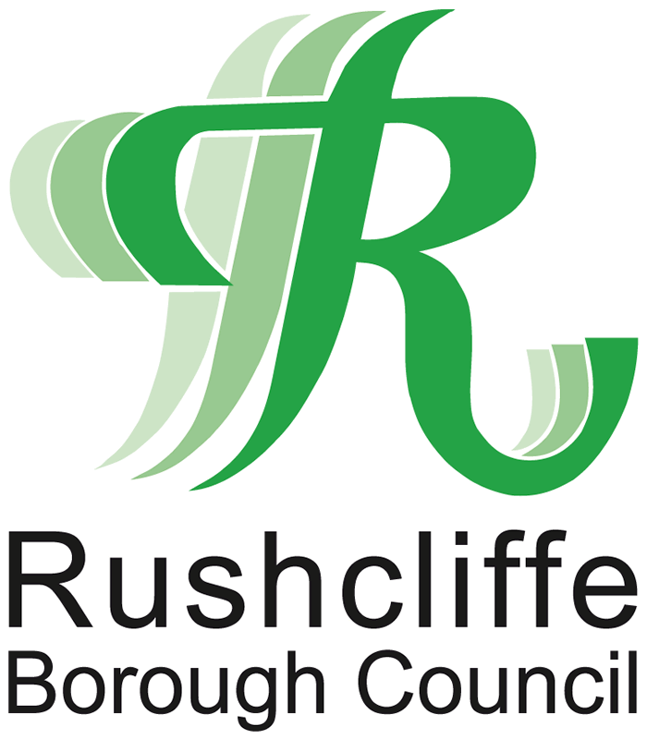
Tollerton Neighbourhood Plan
Ref:

(For official use only)
Regulation 18 Decision Statement

Representation Form

Please return by 23:59 Sunday 27th October 2024 to Planning Policy, Rushcliffe Borough Council, Rushcliffe Arena, Rugby Road, West Bridgford, Nottingham. NG2 7YG, or to: localdevelopment@rushcliffe.gov.uk

This form has two parts –
Part A – Personal Details
Part B – Your Comment(s)

Part A: Personal Details

Consultee Details:

Name:

Organisation:

Address:

Postcode:

E-Mail Address:

If you are an agent acting on behalf of a consultee, please enter your agent details here:

Name:

Organisation:

Address:

Postcode:

E-Mail Address:

If the Neighbourhood Plan document passes Examination and a Referendum, under Section 19 of the Neighbourhood Plan Regulations 2012 (as amended), any person can request to be notified by the Borough Council at the point at which the Neighbourhood Plan becomes adopted. If you wish to be notified please tick the box.

Part B: Comment(s) on the Regulation 18 Decision Statement

Which proposed modification/s does you comment relate to? (You may indicate multiple modifications if you consider this appropriate)
Modification 5 |  | Modification 6 |  | Modification 20

Please use the following space for your comments clearly stating the proposed modification, paragraph or page number you are referring to and the reasons for your comments.
(Please continue on a separate sheet if necessary)

Data Protection Notice

The personal information you provide will only be used by Rushcliffe Borough Council, the Data Controller, in accordance with General Data Protection Regulation 2016/Data Protection Act 2018 to undertake a statutory function (also known as a ‘public task’)

Your personal data will be kept in accordance with the Council’s retention policy and schedule. Details of which can be found on the Council’s website at https://www.rushcliffe.gov.uk/privacy-notice-and-policy/

Your data protection rights are not absolute and in most cases are subject to the Council demonstrating compliance with other statutory legislation, for further information see https://www.rushcliffe.gov.uk/privacy-notice-and-policy/

Representations will be available to view on the Borough Council’s website, but any signatures, addresses, email addresses or telephone numbers will not be included. However, as copies of representations must be made available for public inspection, comments cannot be treated as confidential and will be available for inspection in full.

